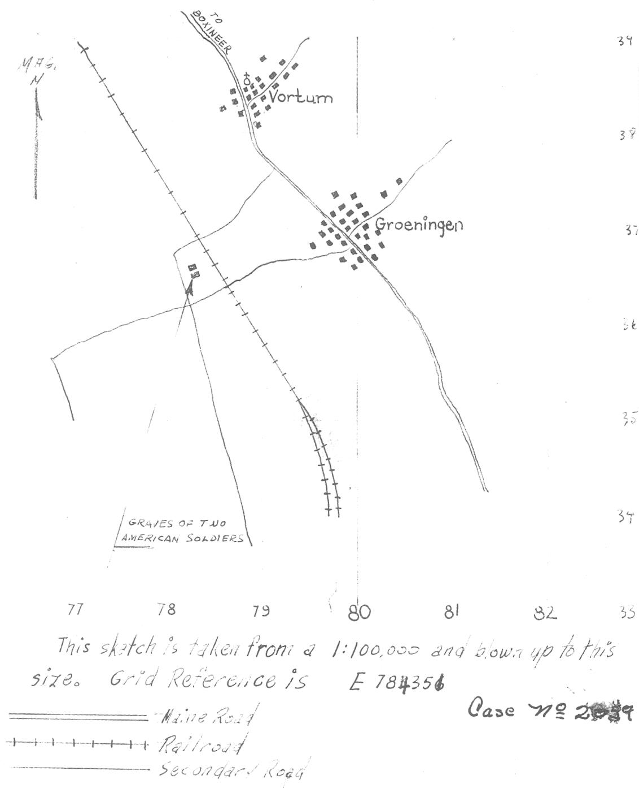

Both men were from Company “C” of 38th Armored Infantry Battalion, killed 4 October 1944. In both cases, the cause of death could not be determined because the bodies were decomposed. A British record dated 2 March 1945 states that they were “buried side by side in one grave near spot where found. Delay in burial accounted for by fact that vicinity heavily mined & apparently under floods for some time previous to our arrival.” So the British buried them 2 March 1945 and reported them. The Americans then recovered the remains and reburied them on 2 July 1945 at Margraten.

Pvt. Luis Gutierrez, 38 583 229, hometown: Vaughn, New Mexico – left a wife and son
S/Sgt. Robert J. Jacob, 31 329 105, hometown: Stratford, Connecticut

Robert Jacob is also interesting because his father wrote a letter to the Army after his son’s death. The father said that Robert Jacob had trained with the 106th Infantry Division at Indianapolis, Indiana (Camp Atterbury). So John Klein might be able to find someone who trained with him, although the 106th lost a lot of men as replacements before the Division ever sailed overseas. The father also said that while Robert Jacob was at Indianapolis, he helped the FBI catch two German spies in Indianapolis. I have never tried to track this one down and verify it, but it sounds intriguing.

