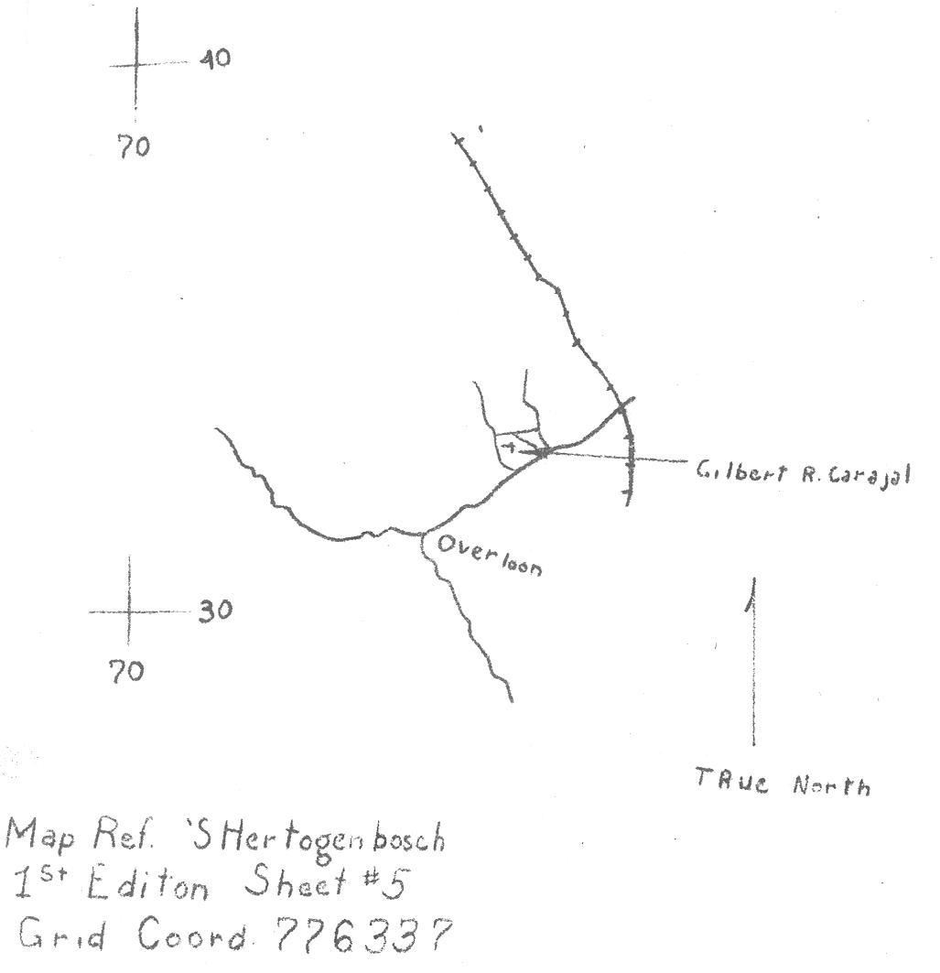

Three B/38 AIB men in same grave, all died on 7 October 1944:
1. Pvt. Gilbert R. Carbajal, 34 560 881, Texas
2. Pvt. Roy E. Dail, 34 854 850, North Carolina
3. Pvt. Garnet L. Smith, 669 323, Margraten
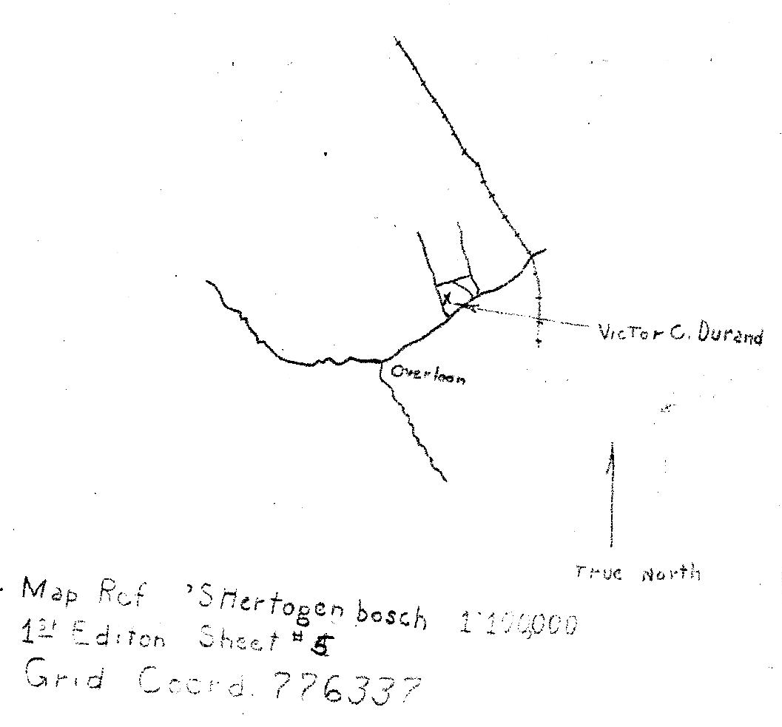

Single grave of B/38 AIB man, died 7 October 1944:
1. Pfc. Viateur C. Durand, 31 148 460, Margraten

Note that even though these were two separate graves, they were both at coordinates 776 337. In all four cases, the records say “... buried behind a farm about 75 yards to the right and near a ditch … QE 776337”.

