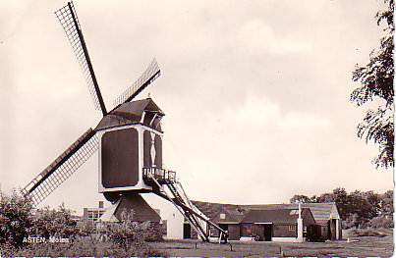

barracks Asten at the mill used by the 7th armored 77th medical Bn (Ray Duke) as movie theater

