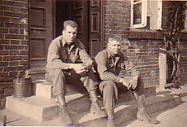
Dan Irish left and George Aaron right HQ 440th Armored Fiel Artillery May 1945 Rehna Germany

