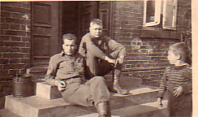
Dan Irish left and George Aaron right HQ 440th Armored Field Artillery Rehna Germany May 1945

