Ransdaal, Holland and Ubach, Germany
Photos taken by Wesley Johnston on September 13-14, 1998
Margraten and Ransdaal, Holland
Photos taken September 13, 1998
The 1st Squad of the Anti-tank Platoon of Company “B” of the 38th Armored Infantry Battalion (7th Armored Division) was quartered at the home of the Brull family in Ransdaal, Holland on the nights of November 24-27, 1944, departing on November 28. This was a period of reorganization for the 7th Armored Division, in reserve behind the front lines. B/38 had suffered very heavy losses in late September at Sillegny, France, in early October at Overloon, Holland, and in early November near Ospel, Holland.
The men in the squad were in an addition to the house that separated the house from the barn. There was a connecting passage from the house to the addition. The squad at that time is believed to have consisted of:

Cpl. Walter J. Gapinski
Pfc. James W. Bateman
Pfc. Thomas G. Boykin
Pvt. or Pfc. Samuel W. Shortt
Pvt. Walter G. Johnston, Jr.
Pvt. Samuel J. Carrubba
T/5 Claud M. Ward

and possibly another member, called “Schultz”. Ward was the driver of the squad’s half-track, “Berlin Bound”.
On the morning of November 27, Pfc. Richard A. Knott, the jeep driver for the Anti-tank Platoon’s commanding officer came to the house with a can of peaches he had taken from the mess truck. It was early; some of the men were up, and some were still laying down. Knott shared the peaches with the men but then jokingly said he was not going to share them with Cpl. Walter Gapinski, of Chicago. Gapinski continued the joke and told Knott that if he did not give him some peaches he would shoot him. He picked up what he believed was his rifle. He knew he had set the safety on his rifle. But there was more than one rifle by the fire place, and he had picked up someone else’s rifle. The safety was not on. When Gapinski pulled the trigger, Knott was killed instantly by a bullet passing from under one arm, through his chest, and out the other side. He dropped to the floor in the doorway between the house and the addition, just to the right of the right-most window on the first floor of the house.
An inquest was held. Pressure was put on the men in the squad to say that Gapinski had intentionally shot Knott. But that was not the case, and the men refused to say otherwise. Gapinski was transferred to the 48th Armored Infantry Battalion, a different unit of the 7th Armored Division. He reportedly later distinguished himself, capturing 8 Germans, and was written up in Stars and Stripes. Nothing further is known of him. Neither he nor his family have been located yet. Richard Knott is now buried at the Margraten United States Military Cemetery in Plot F, Row 20, Grave 13.
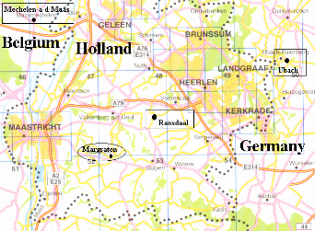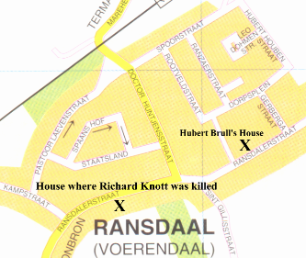
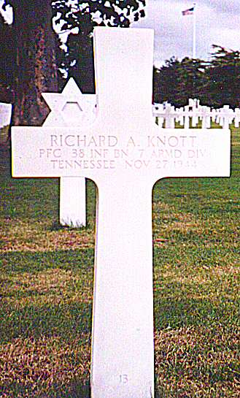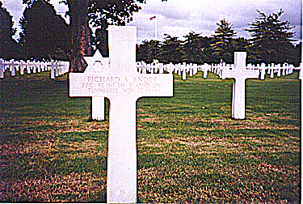
09-08: Richard A. Knott’s Grave at Margraten United States Military Cemetery

Note that the Hubert Brull family does not live in the house where the squad was quartered. Hubert Brull and his family now live at Ransdaalstraat 61 (see map). The house where the men were quartered and Richard Knott was killed is on the opposite side of Ransdaalstraat and a bit over ¼ mile farther south from Hubert Brull’s home. The 1944 house has been renovated inside into apartments. So we were not able to go inside.
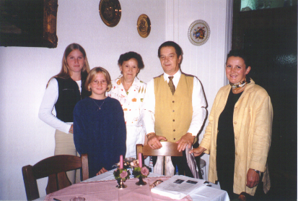
09-16: Hubert Brull Family at Ransdaal, Holland
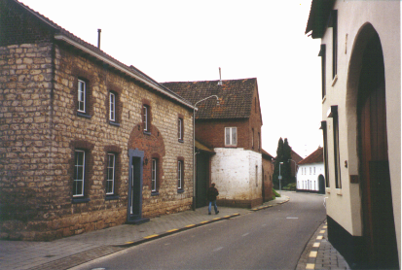
09-17: House, Connection, Addition, Barn
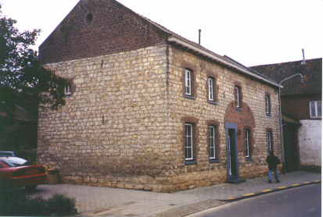
09-18: House and Connection to Addition
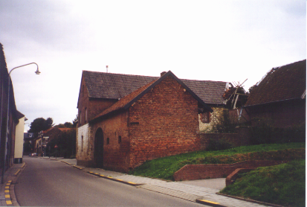
09-19: Barn and Addition
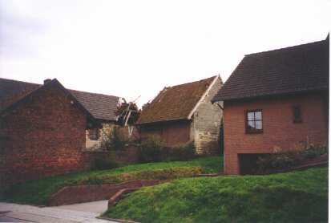
09-20: Barn and behind
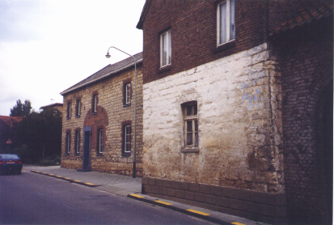
09-21: House and Addition
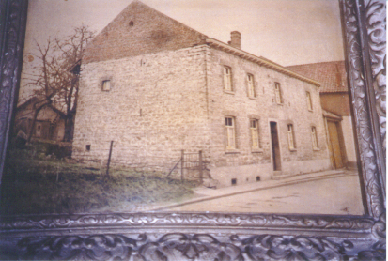
09-22: Old Photo of House

Ubach, Germany
Photo taken September 14, 1998
Company “B” of the 38th Armored Infantry Battalion (7th Armored Division) was quartered at Ubach, Germany. Ubach is just north of Aachen, Germany, the first major German city to be captured in the war. It is just east of the border between Holland and Germany. The Battalion was at Ubach the nights of 28 November – 1 December and 7-16 December, with a trip to Setterich, Germany in between.
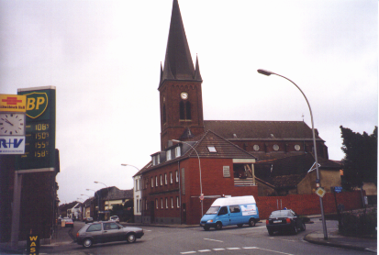
09-23: Church at Ubach

