Sillegny, France
Remains of 9 U. S. (and 43 German) soldiers
Report of Investigation Area Search, 8 April 1946
by Pfc. Glenn Clemmer, 3049th Grave Registration Company
and D. Militch, Interpreter

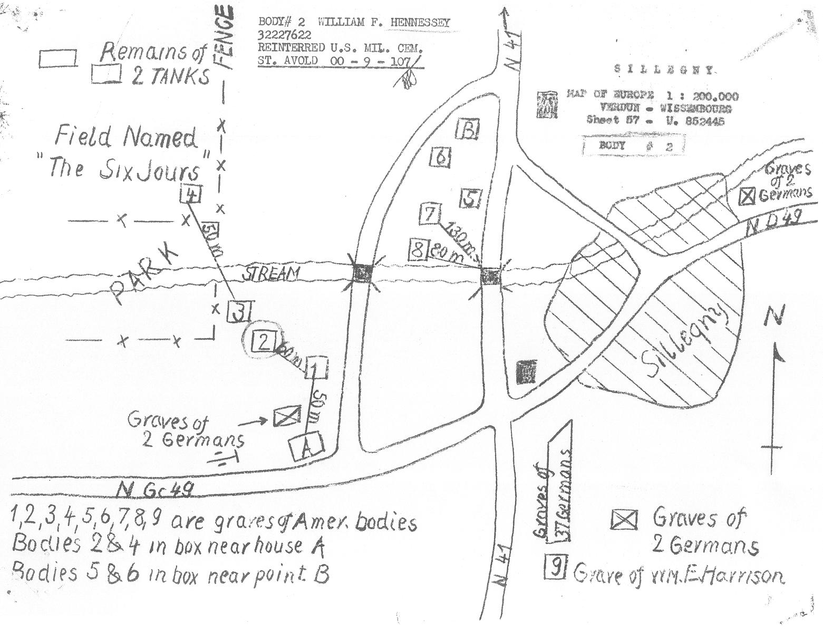

The Germans had removed all civilians from the town of Sillegny before the Americans reached the area. The Germans then laid in mine fields in the open ground to the west of the town. The remains of all bodies 1-4 were found on the surface of the ground in mine fields on which de-mining was not begun until 22 May 1945, by mine sweepers, Jean Benaouda (Chief De-miner), Pierre Cercellier, Edouard Peltzer and Jules Muller, who found some of the bodies. Muller put bodies #2 and 4 (2 on top of 4) into a single casket, which was then moved to location A. Bodies 5 and 6 were put into a single casket, which was moved to location B. The civilians returned to the town once the de-mining was done. The town of Sillegny has now spread, so that the area of #5-8 and B is now built up.

Note that the 9 Americans did not all die on 19 Sep 1944, nor were they all from the same Company. The wide-open ground around Sillegny meant that the battlefield was not in control of either side most of the time. The battle for Sillegny went on for a month. Even when the town was secured (mid to late October 1944 – have to check the exact date, by other US forces, since 7th Armored had left the France for good on 25 Sep 1944), the absence of civilians and the presence of the German mine fields meant that these bodies and those of the Germans were not recovered for a year and a half.

It is also important to keep in mind that this area was also brought under artillery fire a great many times, so that the remains were further damaged after death. Even those believed killed by mines may have been killed by artillery, and vice versa.

- Louis E. Kay, Pfc. 37 099 594, C/38 AIB – 19 Sep 1944 [Report of Interment: Cause of Death: "Multiple wounds". Report of Investigation Area Search: What is the cause of death? “Believed to be mines.” Give basis: “Condition of remains". “Remains found above ground.”] Final burial: Lorraine American Cemetery (St. Avold, France), Plot A, Row 15, Grave 56.
- William F. Hennessey, Pfc., 32 227 622, 1/C/38 AIB – 19 Sep 1944 [placed on top of #4 in same casket and moved to location A] [Report of Interment: Cause of Death: "Multiple wounds". Report of Investigation Area Search: What is the cause of death? “Believed to be mines.” Give basis: “Condition of remains". “Remains found above ground.”] Final burial: Sleepy Hollow Cemetery; North Tarrytown, NY.
- Elias A. Santillanes, Pvt., 38 352 208, Med/38 AIB – 19 Sep 1944 [Based on the April 2004 eyewitness account by Hugh Hays of C/38 of the death of Hennessey and the location of the recovery of Hennessey's and Santillanes' bodies, I conclude that the delayed Morning Report (showing him MIA as of 21 Sep 44 in the MR of 25 Sep 44) – on which the 1946-administratively assigned date of death on 22 Sep 44 was based – was in error and that Santillanes and Hennessey were almost certainly killed by the same artillery shell on 19 Sep 44.] [Mine sweeper Jules Muller’s statement of 3 April 1946: “I can also tell you that the body marked 3, which is still in place, was a medic. I could tell that because he had on his head a helmet with the red cross.”] [Report of Interment: Cause of Death: "Multiple wounds". Report of Investigation Area Search: What is the cause of death? “Believed to be shrapnel.” Give Basis: “Condition of Helmet". “Remains found above ground.”] Final burial: Mt. Calvary Cemetery; Albuquerque, NM.
- Carpenter, Robert E., 1st Lt., O-1 310 065, 1/C/38 AIB – 19 Sep 1944 [placed below #2 in same casket and moved to location A] [Report of Interment: Cause of Death: "Multiple wounds". Report of Investigation Area Search: What is the cause of death? “Believed to be mines.” Give basis: “Condition of remains". “Remains found above ground.”] Final burial: Lorraine American Cemetery (St. Avold, France), Plot A, Row 10, Grave 56.
- Keith Keller K., Pfc., 37 701 757, C/38 AIB – 19 Sep 1944 [placed in casket with #6 and moved to location B.] [Report of Interment: Cause of Death: "Multiple wounds".] [Earlier tooth chart: no date (probably Aug 1944), Co 334/54 Repl Bn.] Final burial: Lorraine American Cemetery (St. Avold, France), Plot A, Row 28, Grave 53.
- Hansen, Frederick W., Pvt., 368 83 490, B/38 AIB – 21 Sep 1944 [Had been Unknown X-6021 Report of Interment: "Multiple wounds KIA". Report of Investigation Area Search: Cause of Death: “Unknown.” “Remains found above ground by mine-sweepers and was put in box in March 1946 with remains of Wm. F. HENNESSEY and moved to side of vacant BLDG.’ Check List of Unknown (1030 8 April 1946): “No skull found. Body was lying together with three other bodies, in a field that had been mined.” Body chart shows no skull, no left arm or shoulder, no left leg below hip, no right arm below shoulder, no left leg from knee down.] [Earlier tooth chart: June 1944, D/255th Inf] [List of stations: Ft. Custer, MI 27 Oct 43 – 28 Oct 43, Cp. Chaffee, AR 31 Oct 43-3 Jun 44, Ft. Meade, MD 6 Jun 44 – 14 Jun 44, Cp. Van Dorn, MS 16 Jun 44 – 22 Jul 44, Ft. Meade, MD 24 Jul 44 – 3 Aug 44.] Final burial: Lorraine American Cemetery (St. Avold, France), Plot A, Row 13, Grave 62.
- Harry Klosin, Pvt., 12 024 013, C/38 AIB – 19 Sep 1944 [placed in casket with #5 and moved to location B.] [Had been Unknown X-6020; Report of Interment: Cause of Death: "Multiple wounds". Report of Investigation Area Search: What is the cause of death? “Unknown”. “While searching in this area, some children showed us some G. I. equipment protruding from the ground. I investigated and saw it was the remains of an American Soldier in a shallow Grave.” Teeth and skeletal charts: posthumously missing lower left mandible (including tooth 9 on right), teeth 1-2 on upper right and teeth 9-13 on lower right, also missing left hand and foot on one chart and both hands on another chart. Earlier tooth charts: Aug 1943 in H/399 Inf, Mar 1944 in HQ Co/JBS] [Review of Circumstances Surrounding Disappearance (29 Dec 1949): “A Missing Report filed in AG [Adjutant General] files … shows that he departed with his company on 19 September 1944 from a point one and one quarter miles east of Marieulles, France on a mission to support tanks in an attack on a fortified position. The intended destination was Sillegny, France. The report contains the following …: ‘Leading element crossed L.D. [Line of Departure] at 0200. This man as part of the supporting platoon of Infantry was last seen at the L.D. Because of heavy enemy fire and small arms fire and also because of darkness proper control was impossible. This platoon was supporting the right flank of the attack. When the Company was withdrawn and a roll call made, this man was not present.’ The report concludes: ‘The tactical situation would not permit a search to be made.’’] Final burial: Woodlawn National Cemetery; Elmira, NY; Section G Grave 4462.
- Fidel Flores, Pfc. 38156148, A/38 AIB – 19 Sep 1944 [Report of Investigation Area Search: items 10-20, including cause of death, missing. Report of Interment: "Multiple wounds". (Probably by artillery, since testimony says he was in un-mined area at Sillegny.)] Final burial: Lorraine American Cemetery (St. Avold, France), Plot C, Row 20, Grave 89.
- William E. Harrison, Pvt., 34 931 992, 10th Inf Regt (5th Inf Div) – 13 Oct 1944 [Report of Interment: Cause of Death: "Multiple wounds". Report of Investigation Area Search: buried under a “German military burial marker”. What is the cause of death? “Unknown”.] Final burial: Lorraine American Cemetery (St. Avold, France), Plot K, Row 26, Grave 11.

