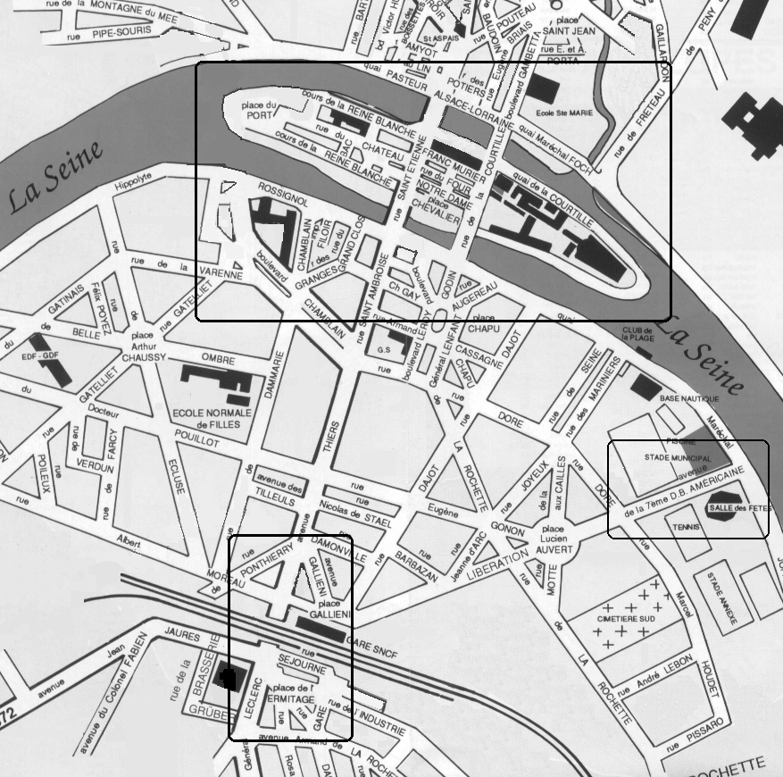
38th Armored Infantry Division Action at Melun, France on August 22-25, 1944.
Immediately after 38 AIB arrived, they were thrown into a surprise attack against the railroad embankment and viaduct at the southwest edge of Melun (bottom center). They were beaten back by strong defenses. Eventually, they succeeded in entering the city, only to find the bridges across the Seine River had been destroyed. Though the orders were to not drive the Germans out, so that CCA of 7th Armored Division could make a surprise encirclement from the north, XX Corps Commander Gen. Walker, who was ignorant of the plan, visited the front and personally ordered 38 AIB into combat to seize the island and cross the Seine (top center) on August 23. This had the doubly negative effect of creating many unnecessary casualties and of preventing the entrapment of the Germans in the city. Making matters worse, Gen. Walker and Gen. Patton then prided themselves on Gen. Walker having “inspired the troops” and used this incident to criticize the 7th Armored Division, instead of admitting Gen. Walker’s grievous error. The map is a modern map, with new RN6 bridge removed. The commemorative Avenue of the 7th Armored Division is also highlighted (lower right). At least the French people gave credit where it was due.

