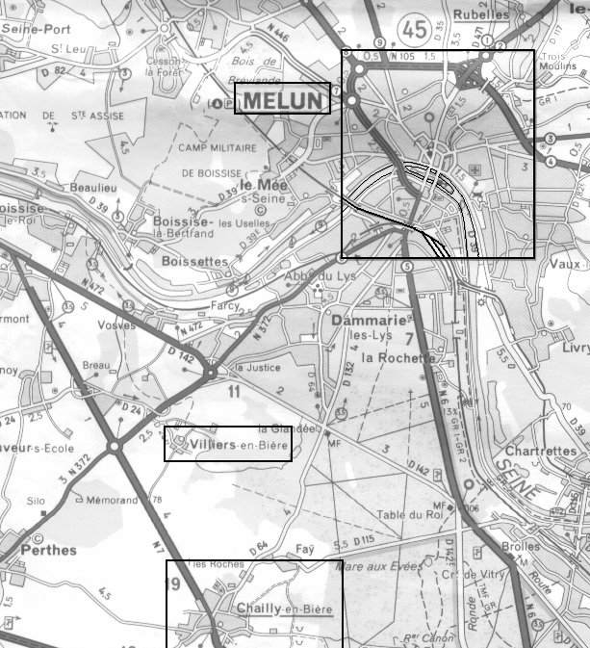
38th Armored Infantry Division Moves into Action at Melun, France on August 22, 1944.
Immediately after 38 AIB arrived, they were thrown into a surprise attack against the railroad embankment and viaduct at the southwest edge of Melun (bottom center). They attacked from the southwest. They were beaten back by strong defenses. They then used used the area 3 miles southwest of Melun, near Chailly, as a bivouac the night of 22-23 August. They bivouaced in Melun on 23-24 August. (C/38 was separate from the Battalion and bivouaced 1 mile west of Chailly on 22-23 August and then 2 miles east of Villiers on 23-24 August.) The nights of 24-25 and 25-26 August, the Battalion were bivouaced together (including C/38) 3 miles southeast of Melun, except for B/38 which on the night of 25-26 August was in Melun. On 26 August, the Battalion moved out of the immediate Melun area for assembly, except B/38 which remained north of Melun, along the Seine at Tilly. On August 27, the entire Battalion moved east from Melun. This is a modern map; the super-highway and its bridge were not there during the war.

