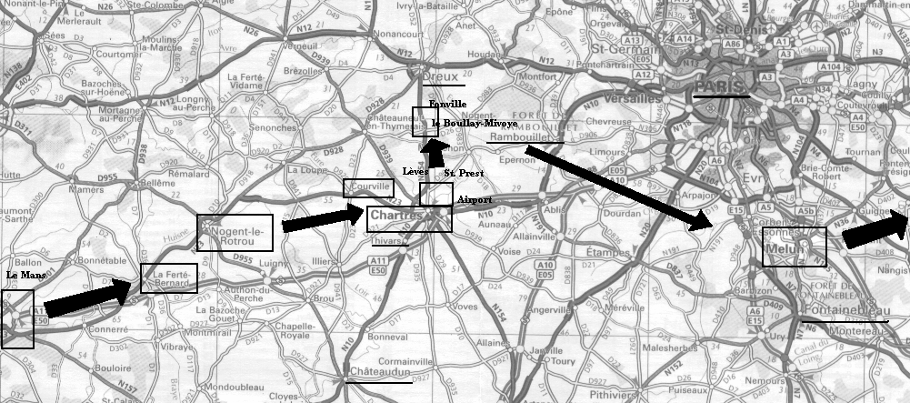
38th Armored Infantry Division Moves into Combat South of Paris, August 1944.
38 AIB came ashore on Utah and Omaha Beaches in Normandy on August 11-12, two months after the D-Day invasion. They assembled in Normandy at la Haye du Puits (off map to west) on August 12 and moved to Lundean August 13 (not on map). They moved to Le Ferté-Bernard (at left side of map) on August 14 and 2 miles southwest of Courville on August 15. The first combat came on August 16, north of Chartres at Lèves and south of St. Prest, as they attempted to encircle the airport from the north. C/38 and Headquarters Companies were involved in these actions. A/38 lost their first man east of the airport on August 18. The nights of August 19 and 20 were spent south of Dreux near Fonville and then la Billouay-Mivoye (except C/38 at Marville both nights). The orders were then to speed to Melun and secure a crossing of the Seine River south of Paris. 38 AIB was in combat at Melun August 22-25. Following a day of assembly, the Battalion then moved east (off the map) on August 27, toward Verdun and Metz. Some other important places are underlined, though 38 AIB was not at these places. At Thivars, a famous photograph of 7th Armored Division Gen. Silvester meeting with XX Corps Gen. Walker was taken. North of Châteuadun, the 7th Armored Division’s 23rd AIB was ambushed. Rambouillet has a monument that includes the 7th Armored Division, since members of the Division were killed liberating the city. Fontainbleau was XX Corps Headquarters and near where the Battalion was on August 26. This is a modern map; the super-highways did not exist in 1944.

