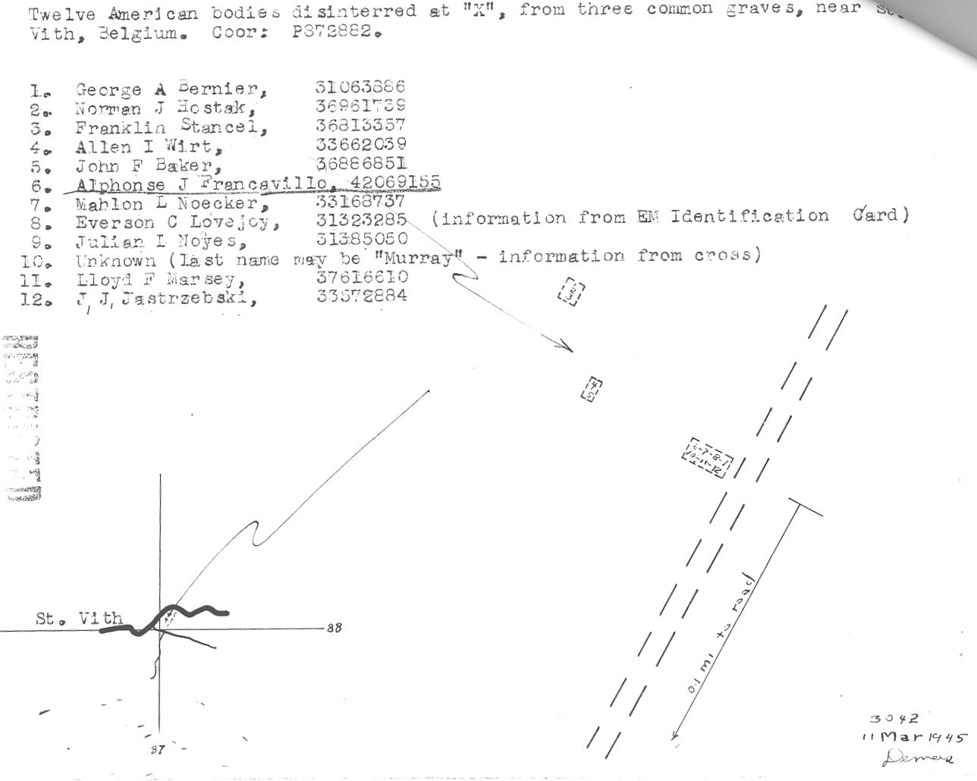
St. Vith Burials of Baker, Francavillo, Marsey and 9 others
[Rank, Name (ASN) – Unit (bold =non--7AD; red – 38 AIB) – Date of Death – Burial]

- Pvt. George A. Bernier (31 063 886) – B/87th Recon – 22 Dec 44 – Henri-Chapelle
- Norman J. Hostak (36 961 739) – 1/F/423 (106th Inf Div) – 17 Dec 44 – St. Mary’s Cemetery; Algoma, WI
- Cpl. Franklin Stancel (36 813 357) – B/87th Recon – 22 Dec 44 – Green Ridge Cemetery; Kenosha, WI
- Allen I. Wirt (33 662 039) – HQ Co/23 AIB – 22 Dec 44 – Sunset Cemetery; Christiansburg, VA
- Pfc. John Fremon Baker (36 886 851) – B/38 AIB – 21 (officially 23) Dec 44 – International Order of Odd Fellows Cemetery; Clay, KY
- Pvt. Alphonse John Francavillo (42 069 155) – B/38 AIB – 21 (officially 23) Dec 44 – Long Island National Cemetery
- Mahlon L. Noecker (33 168 737) – A/23 AIB – Bern Church Cemetery; Bern Township, Berks County, PA
- Pfc. Everson C. Lovejoy (31 323 285) – 168th Engr – 17 Dec 44 – Long Island National Cemetery
- Julian I. Noyes (31 385 050) – C/168th Engr – worked on machine gun – 17 Dec 44 – Greenwood Cemetery; Coventry, RI
- Murray -- 168th Engr – worked on machine gun -- no William or Bill Murray on ABMC; no Murray of 168th on ABMC: so buried in US
- Pfc. Lloyd F. Marsey (37 616 610) – B/38 AIB – 21 (officially 23) Dec 44 – Henri-Chapelle
- John J. Jastrzebski (33 572 884) – C/168th Engr – 17 Dec 44 – Arlington National Cemetery

