October 23, 2006

Mr. Tom Sole, Director of Engineering and Maintenance
American Battle Monuments Commission
Courthouse Plaza II
Suite 500
2300 Clarendon Boulevard
Arlington, VA 22201

Subject: Privately-Funded Memorial Monument, Baraque de Fraiture, Belgium

Dear Mr. Sole:

Pursuant 36 CFR Part 401, I am submitting this formal request for approval of a new private memorial to be erected at the crossroads located in Baraque de Fraiture, Belgium. The new private memorial will honor the WWII veterans who defended this strategic crossroads at the outset of the Battle of the Bulge. Specifically, the units to be honored are as followed:

- Troop D, 87th Cavalry Reconnaissance Squadron (Mechanized), 7th Armored Division
- Battery D, 203rd Anti-Aircraft Artillery, 7th Armored Division
- Company F, 2nd Battalion, 325th GIR, 82nd Airborne Division

I will now take this opportunity to address the ABMC eight (8) specific evaluation criteria that are set forth in '401.9 of the regulation.

- Q: How long has it been since the events to be honored took place?
A: 62 years. The five day battle to control the strategic crossroads at Baraque de Fraiture, Belgium took place December 19-23, 1944.

- Q: How will the perpetual maintenance of the memorial be funded?
A: The privately-funded memorial monument will be maintained by the County of Vielsalm, Belgium. The County of Vielsalm has already committed to a memorial site at this crossroads. As you will note in Exhibits 2 and 4, respectively, the current memorial site is comprised of a grass lawn that has a gravel bounded area and an inset star-shaped concrete pad. Around the rim of the bounded area there are three flag poles one for the U.S., Belgian, and EU flags. To either side of the flag poles are Belgian shale stones with brass plaques affixed to each stone. In 1994, the U.S. Army decommissioned and provided one of the original 105mm howitzer cannons that defended this crossroads to this memorial site. That cannon sits atop the star-shaped concrete pad. The site has been supplied with electric power that runs to spot lights to illuminate each of the memorials. As you will further note in Exhibit 4, the County of Vielsalm has already stood up and anchored in concrete a new piece of Belgian shale stone to honor the men set forth in this request.

The Centre de Recherches et d'Informations sur la Bataille des Ardennes" (C.R.I.B.A.) has agreed to take responsibility in the preparation of the two, new bronze plaques that will be affixed to the shale stone honoring these three units. This private association, founded in March 1980, is a non-profit, a non-political and non-philosophical organization. http://www.criba.be.

- Q: Has the host nation consented?
A: Yes. The County of Vielsalm government voted on May 9, 2006 to approve erecting a new memorial monument at the existing memorial site at Baraque de Fraiture crossroads. The proclamation, provide in both the English (translated) and original French languages, is set forth in Exhibit 3 herein. To that end, the County of Vielsalm is so committed to this project that the county has already procured a large piece of Belgium shale stone, and has permanently anchored and set the stone in concrete at the existing memorial site. Digital photos of the existing memorial site with the new memorial monument are set forth in Exhibit 4 herein.

- Q: Is an overseas site appropriate for the proposed permanent memorial?
A: Yes. The battle in question took place at the crossroads at Baraque de Fraiture, Belgium. Therefore, this site would be appropriate for this permanent memorial monument.

- Q: Is the proposed memorial intended to honor an individual or small unit?
A: Yes. The memorial is intended to honor three units from two U.S. divisions who were on the front line at the onset of the Battle of the Bulge. The current memorial specifically honors the 589th FAB, 106th Infantry, U.S. Army. This new memorial attempts to honor and recognize the other units/divisions that were part of this “Alamo defense” to block this strategic crossroads. This crossroads garrison was comprised of several small units with limited resources. The garrison never totaled more than 400 men at any given time and was up against superior forces in the form of the two enemy divisions: the 2^{d} SS Panzer Division and the 560th Volks Grenadier Division. As the 3rd Armored Division tanks pulled out and withdrew north along the N-15 highway to Manhay, one tanker yelled out “There’s nobody between you and Germans now.”

Originally, the garrison’s orders were to “Hold for 24 hours” which then became “Hold as long as you can.” The Baraque de Fraiture crossroads was the boundary between the 3rd Armored Division and the 82nd Airborne Division. The 2^{d} SS Panzer Division was intending to proceed north up the N-15 to Leige and onto capturing the ports at Antwerp thus allowing the German Army to split the U.S. and British forces. Once the Allied High Command figured out the strategic importance of this crossroads and highway to the German Army’s likely objective, the order was raised to “Hold at all costs.” The brave soldiers of this crossroads garrison repealed and delayed the enemy’s advances for five days before succumbing to an all out attack by superior forces of German armor and infantry that had nearly surrounded the crossroads. Just before the crossroads fell into German control, the order to withdraw was finally given. The surviving U.S. forces totaled approximately 55 men who either escaped or became POWs.

1st Lt. Horst Gresiak, tank commander, 2nd SS Panzer Division, who lead the final assault on the crossroads stated “… although brief, the most violent and toughest battle I experienced during the entire war. […] It was hell, an inferno. It was like a terrible storm, like the end of the world.” Astor, Gerald, A Blood-Dimmed Tide, pp. 272.

The evidence and after action reports supports that the services of these units clearly were of such distinguished character as to warrant a separate memorial in their honor.

- Q: Is the memorial historically accurate?
A: Yes. The representations made herein are supported by the following objective authorities, related Web sites, and personal interviews with the few surviving veterans from this battle:

The 7th Armored Division Association, The Seventh Armored Division in the Battle of St. Vith, (1948), pp. 34-36

Cole, Hugh M., The Ardennes: The Battle of the Bulge, pp.388-392

Parker, Danny S., Battle of the Bulge: Hitler’s Ardennes Offensive, 1944-1945, pp. 202-212

DuPuy, Trevor N., Hitler’s Last Gamble: The Battle of the Bulge, December 1944-January 1945, pp. 159-160

Astor, Gerald, A Blood-Dimmed Tide: The Battle of the Bulge by the Men Who Fought It, pp. 267-274

http://members.aol.com/dadswar/baraque-7ad.htm

http://www.indianamilitary.org/106ID/ParkersXRoad/ParkersXRoad.htm

http://www.indianamilitary.org/106ID/ParkersXRoad/OJT%20book/OnTheJobTraining.htm

http://ice.mm.com/user/jpk/men589th.htm

The proposed wordings for the two bronze plaques reflect this memorial monument’s historical accuracy and are set forth in Exhibit 1 herein.

- Q: Is the proposed memorial intended to honor an organizational element of the American Armed Forces rather than soldiers from a geographic area of the United States?
A: Yes. The proposed memorial monument is fully intended to honor an organizational element of the American Armed Forces. A geographic area of the United States is not a factor nor addressed in this proposed memorial monument.

- Q: Does the contribution of the element to be honored warrant a separate memorial?
A: Yes. The existing memorial monument primarily honors the brave men of the 589th FAB, 106th Infantry, U.S. Army and their commanding officer Major Arthur C. Parker III. A bronze plaque honoring the 3rd Armor Division was affixed several years later. Given the facts of this case, I would be of the opinion that the men of these identified units deserve and warrant their own separate memorial honoring their bravery in the face of superior forces. Further, I believe it would be fair to say that gallant and selfless efforts of the units at this crossroads garrison probably saved countless lives of the Allied Forces and bought the Allied High Command enough time to adjust and move its troops into position to blunt the German attack.

On behalf of the 7th Armored Division Association, the 325th GIR Association, C.R.I.B.A., and the County of Vielsalm, Belgium, I believe that we have satisfactorily addressed all of the ABMC’s evaluation criteria and concerns pursuant to 36 CFR Part 401. Thank you for your timely consideration to this request. It is the collective hope of all of the associations and local government represented here that the ABMC will approve this privately-funded memorial monument for the Baraque de Fraiture crossroads. If you have any further questions or comments please do not hesitate to contract me directly.

Sincerely,

/s/ P. Schreiber

Cc:
EXHIBIT 1
Proposed Wording for Bronze Plaques

In Memory of the Brave Soldiers of

D Troop, 87th Cavalry Reconnaissance Squadron (Mcnz),
7th Armored Division.
D Battery, 203rd Anti-Aircraft Artillery Battalion,
7th Armored Division.
F Company, 325th Glider Infantry Regiment,
82nd Airborne Division.

Who defended this critical crossroads
against overwhelming forces
during the period 19-23 December, 1944.

Their courageous defense against repeated attacks
bought invaluable time for the defense of the Ardennes.

Their bravery in fierce battle when heavily outnumbered
continues to inspire their allies and their countrymen.
EXHIBIT 2
Existing Memorial Monument at the Baraque de Fraiture Crossroads

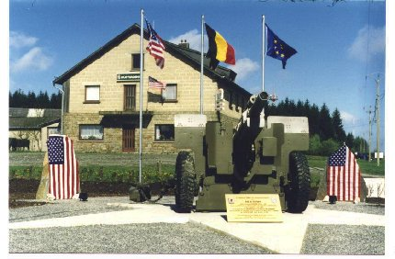
Monument erected by the C.R.I.B.A. on May 7th, 1994 at the Baraque de Fraiture (Belgium)

EXHIBIT 3
Proclamation of the County of Vielsalm, Belgium
(French to English Translation)

Province of Luxembourg Bastogne Arrondissement (District)

Town of Vielsalm

Excerpt from the Register of the Proceedings of the “Town Council”

Meeting of May 9, 2006

Present: Mr. LG, Burgomaster (“First Selectman”)
Mr. RL, Miss SH, Deputy Burgomasters
Mrs. A-CP, “Town Clerk”

Re: Meeting with CRIBA, Erection of a monument at the Baraque de Fraiture, Construction, Cost responsibility

The Town Council,

Having seen the Burgomaster’s note dated May 8, 2006, concerning his meeting with CRIBA on April 24, 2006,

Considering that after contact with the children of a war veteran, a new monument could be erected at the Baraque de Fraiture (base in shale plus a plaque honoring the 7th Armored Division and the 82nd Airborne),

Considering that the Town would take care of supplying and placing the stone, as well as planning of the location,

Considering that CRIBA would be responsible for the cost of the commemorative plaques,

HAS DECIDED

To register its agreement to the above-mentioned proposals by the Burgomaster and to mandate CRIBA to write the text which will appear on the monument.

By the Council,

Secretary, President

A-C P. J. G.

Proclamation of the County of Vielsalm, Belgium
(Original French Language)

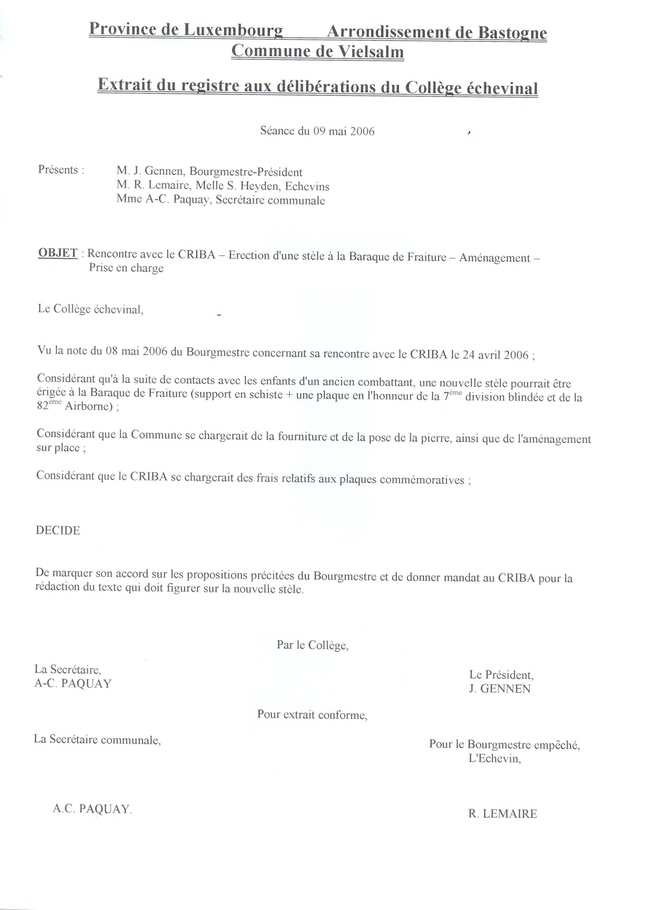

EXHIBIT 4
New Stone Memorial Monument at Existing Memorial Site

