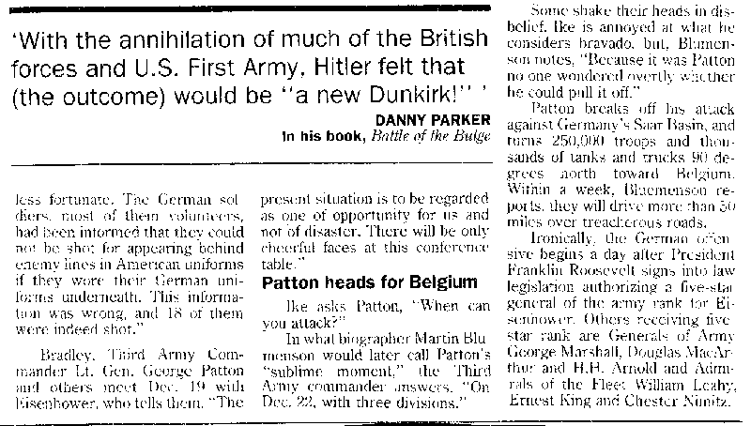
Palm Beach Post, Sunday 18 December 1994

