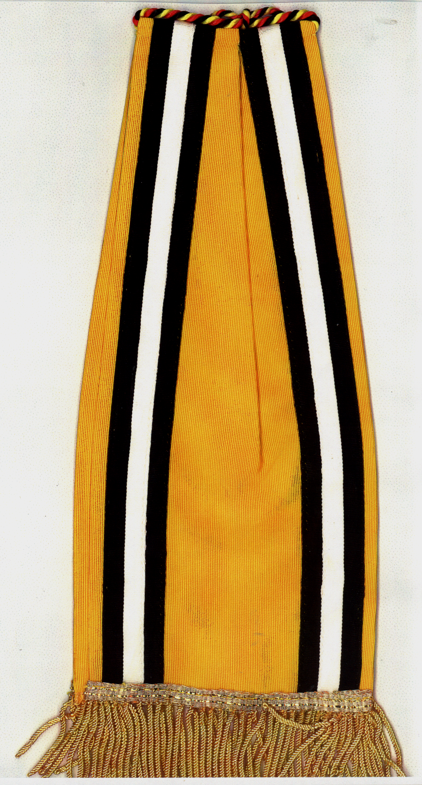
603 QM GR CO Belgian Meritorious Streamer, WW II (For Guidon)

