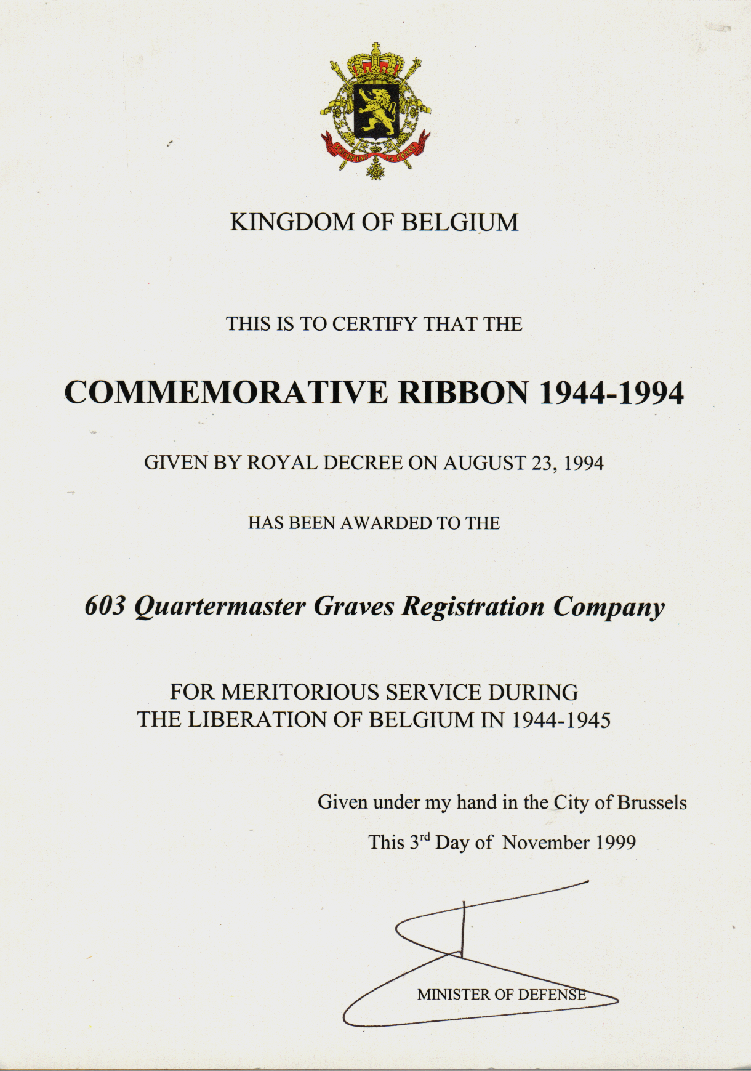
603 QM GR CO, Belgian Meritorious Award, WW II

