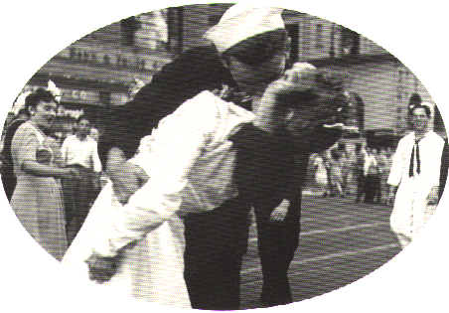
The End Of World War II, VJ Day, Times Square, New York, 1945

