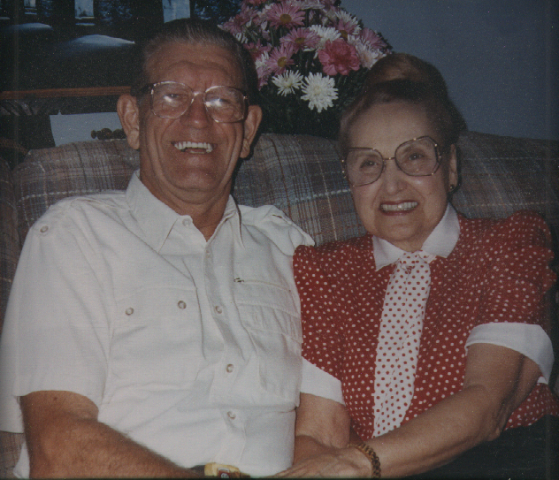

50th Wedding Anniversary, 22 October 1992, Little Hocking, OH

