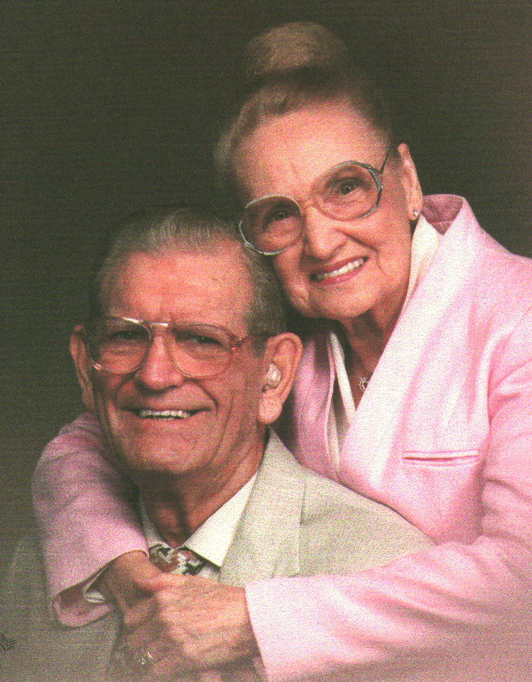
Velma and Bud Butte, October 1997

