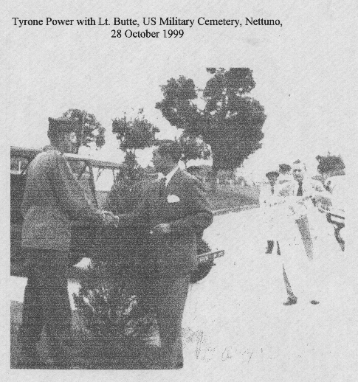
SICILY SEARCH and RECOVERY PHOTO #7

