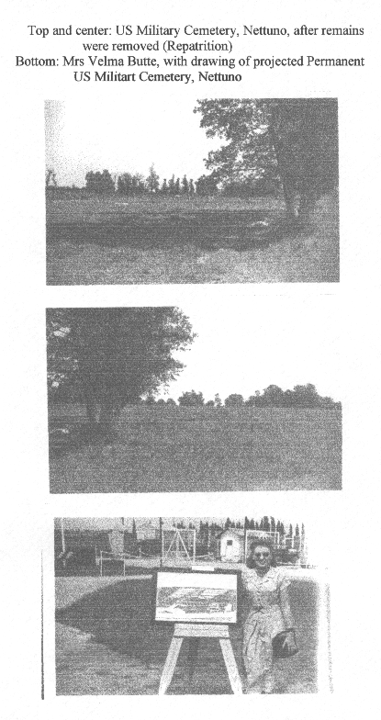
SICILY SEARCH and RECOVERY PHOTO #6

