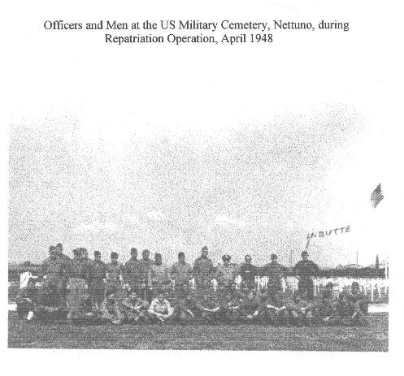
PERSONNEL, REPATRIATION, US MILITARY CEMETERY, NETTUNO

