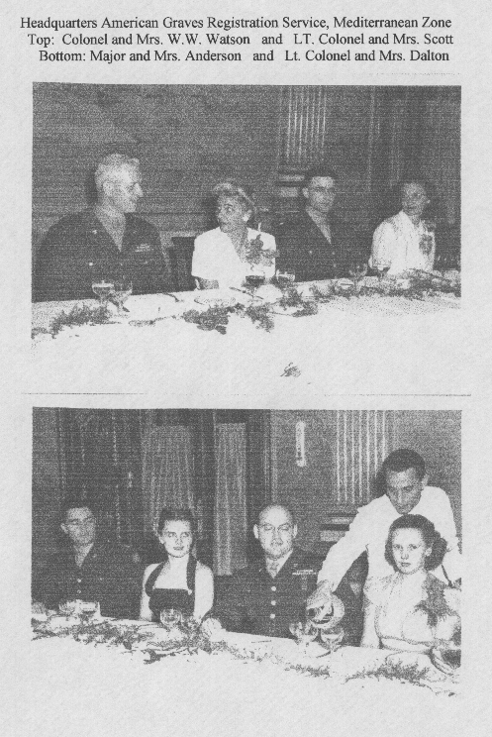
SICILY SEARCH AND RECOVERY PHOTO #2

