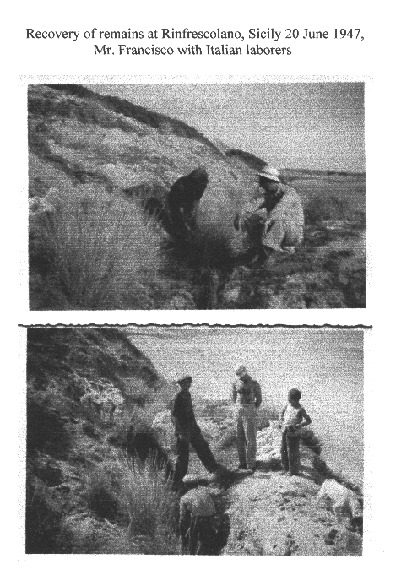
SICILY SEARCH AND RECOVERY PHOTO #1

