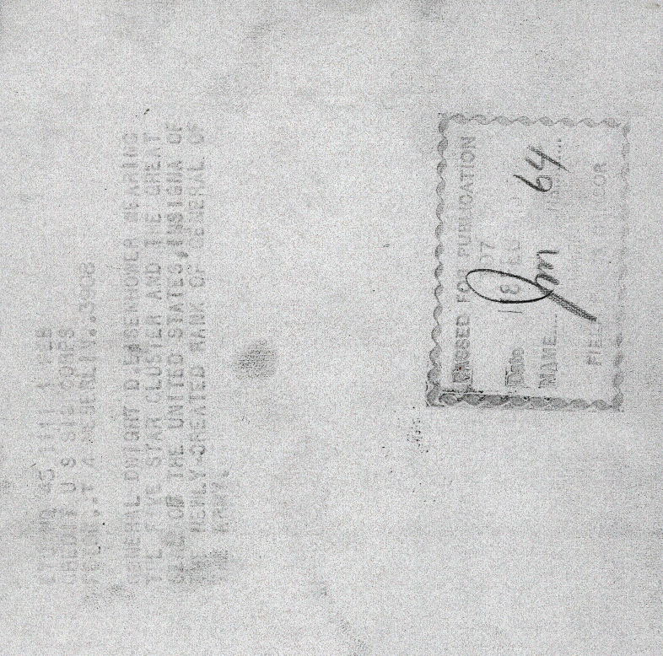
Picture of General Of The Army Dwight D. Eisenhower on the day he was promoted to Five Star General
US Army Signal Corps Photo.

