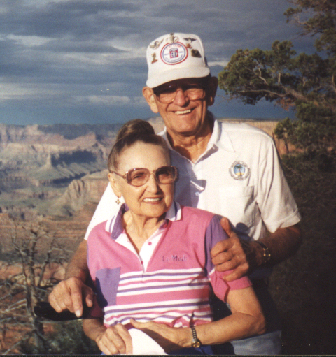
Bud and Velma
Grand Canyon
August 1999

