Charles D. Butte, Retirement, Fort Eustis, Virginia, 28 February 1967,
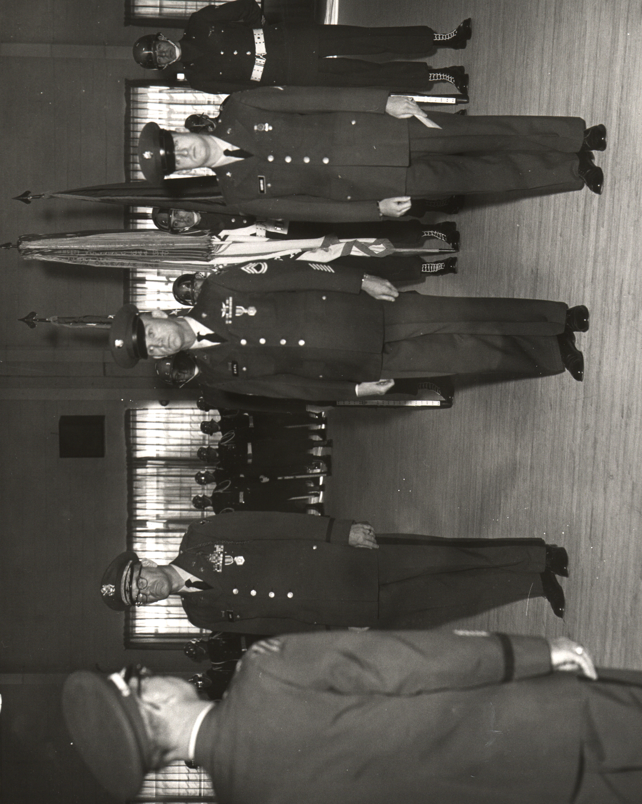
(Ceremony inside, no parade today, Bad weather).

