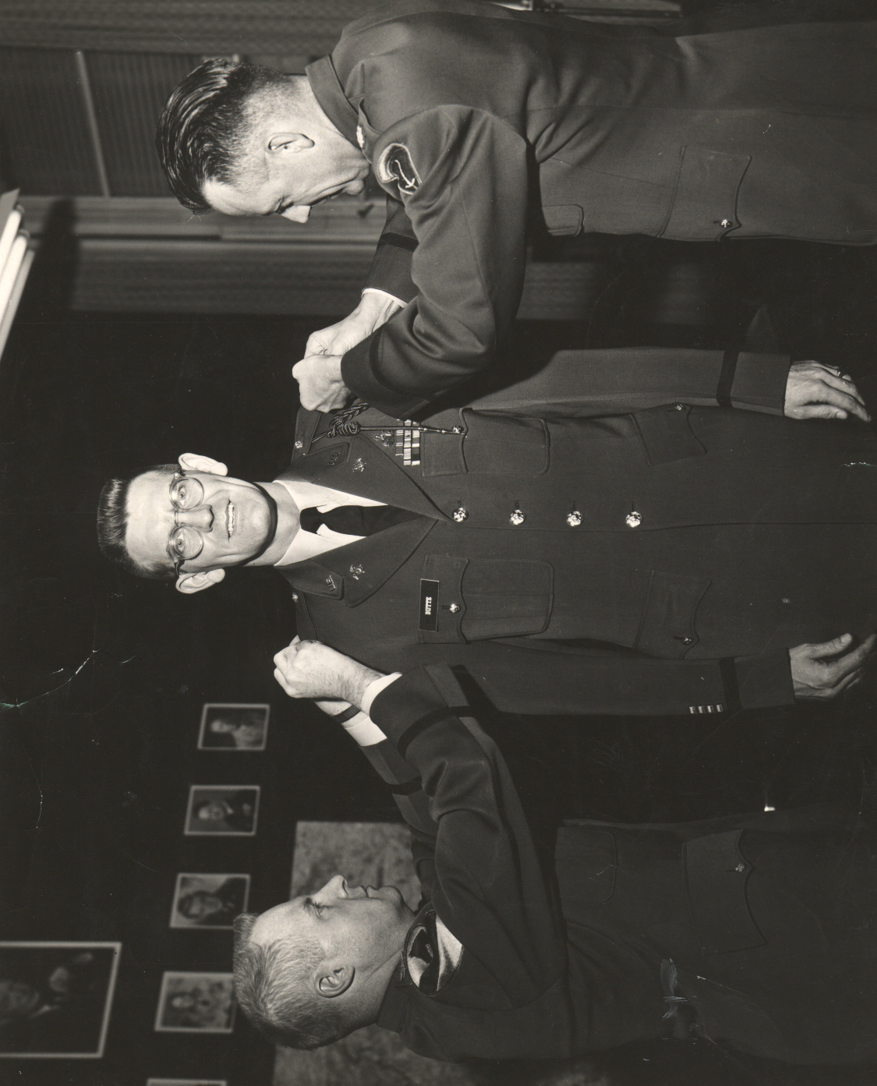
Charles D. Butte, Promotion to Major, 7 December 1960, left-Col. Max Kirkbride Chief of Staff, Headquarters Northern Area Command, Frankfurt, germany, right-LTC J.C.Bagg, Quartermaster same Headquarters.

