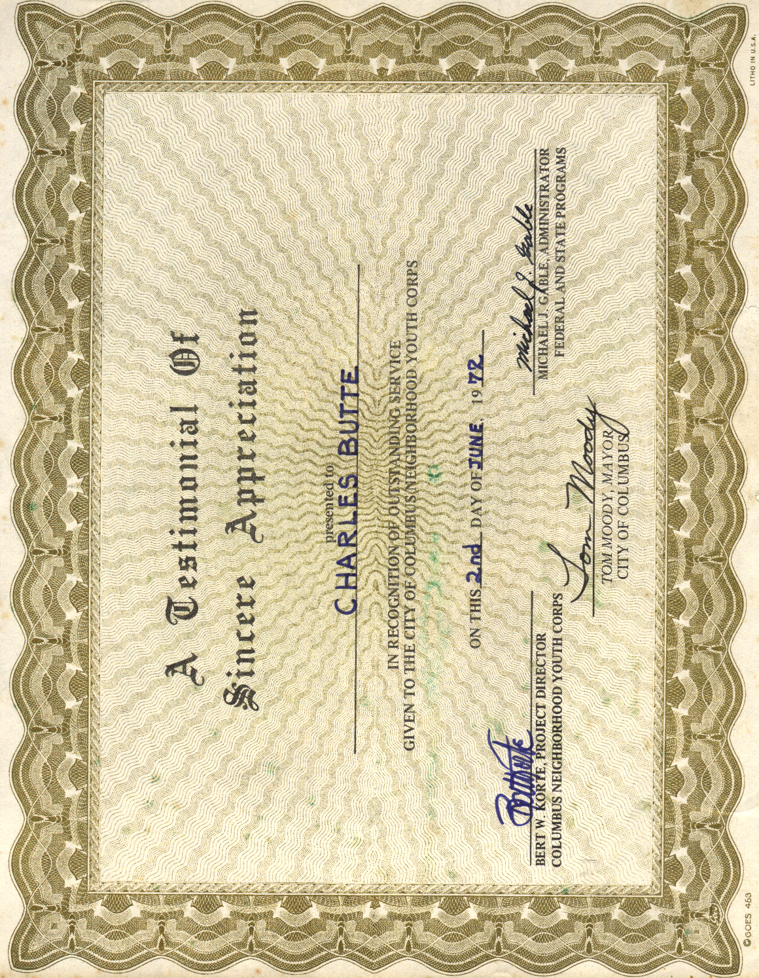
Bud, Certificate of Appreciation, Columbus Youth Corps, 2 June 1972

