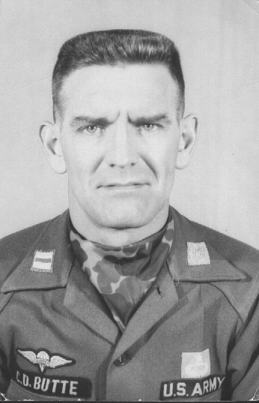
Charles D. Butte, Captain, USA QMC, Korea 1956

