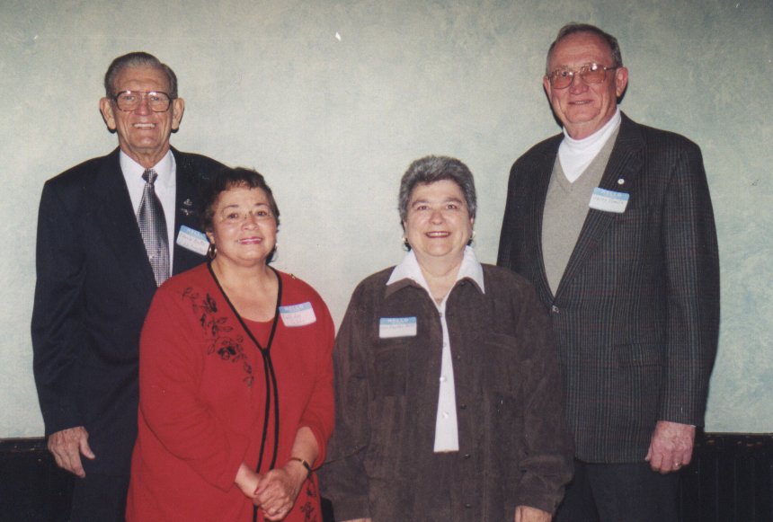

Inductees, West High School Alumni Association Hall of Fame 13 Oct 2000
Charles D. Butte, Ruth Ann Gibbs for Jack Gibbs (deceased) Lois Hunter and Gerald R. Smith

