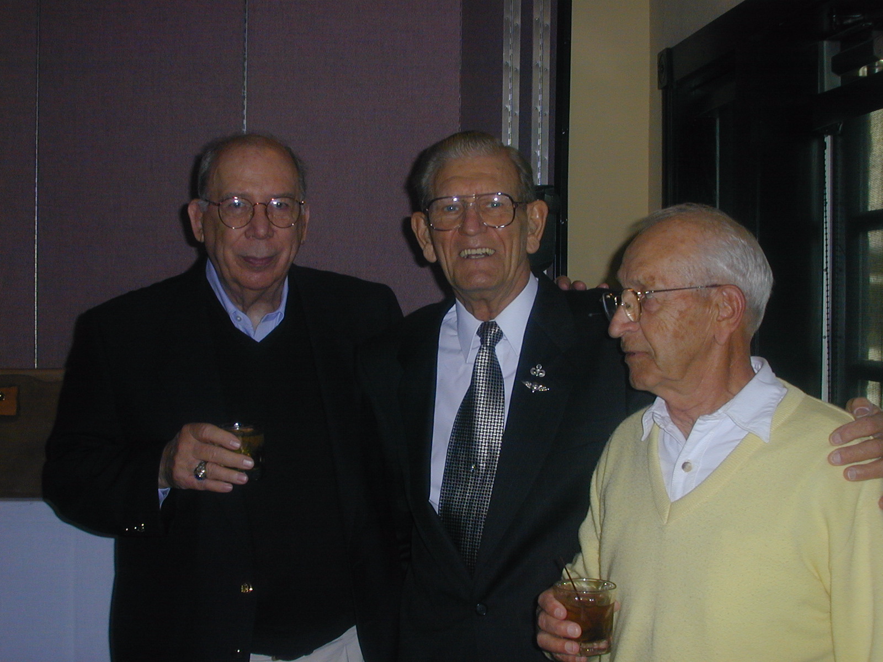
Skip Forbes; Bud Butte; Harry Riggs DVM, President of the Class of 1938 West High School, Columbus, Ohio; Hall of Fame induction, Bud Butte
13 October 2000.

