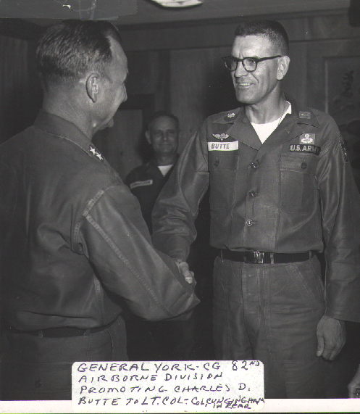
Fort Bragg, NC, November 1962

