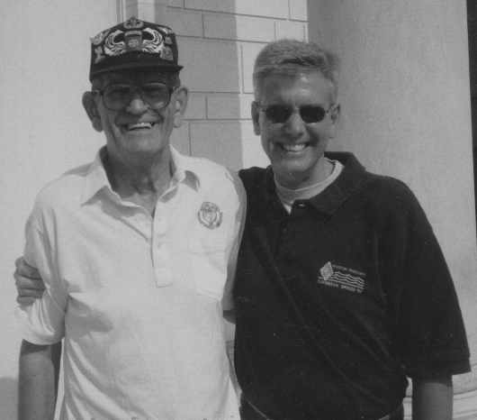
Bud and Chuck, Arlington National Cemetery, Alexandria, VA 20 May 1998

