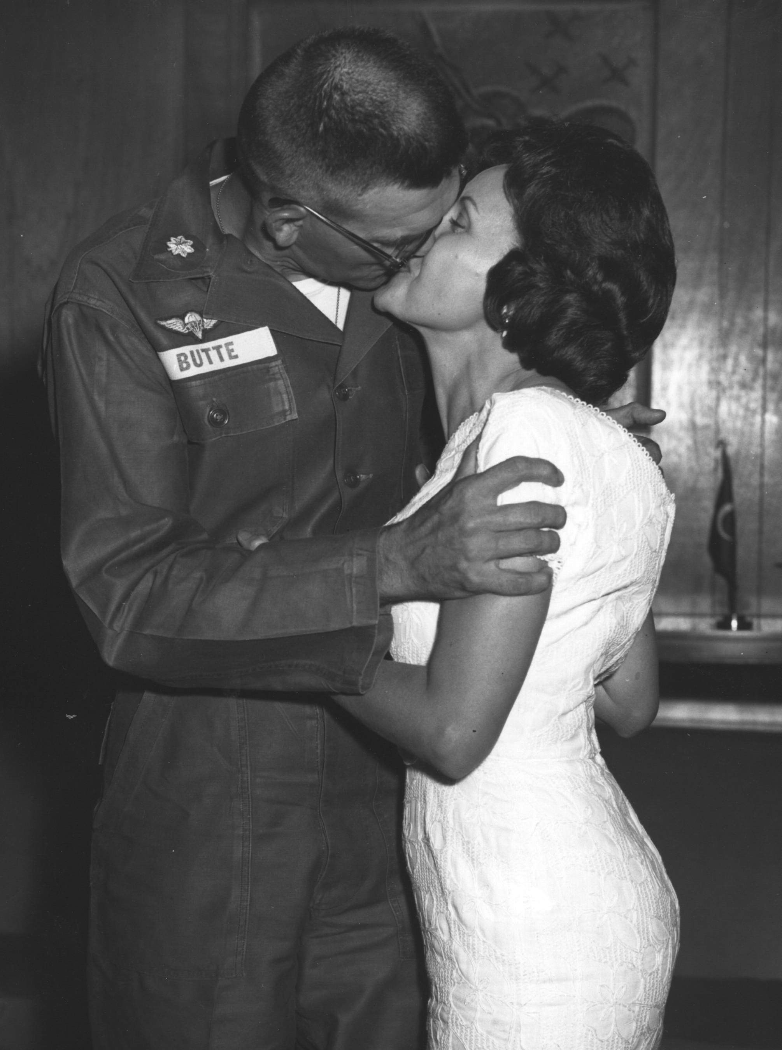
Bud, Promotion to LTC, Ft. Bragg, NC 17 July 1964
This being the year, 2000, for National Elections,
would you vote for me for President?

