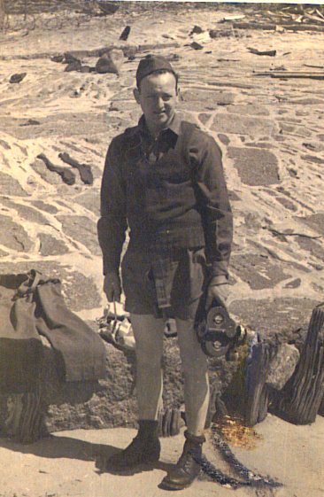

George Hebenstriet, Army Pictorial Service #146, Cherbourg, France, June 1944, during the lying of the communication cable between England and France

