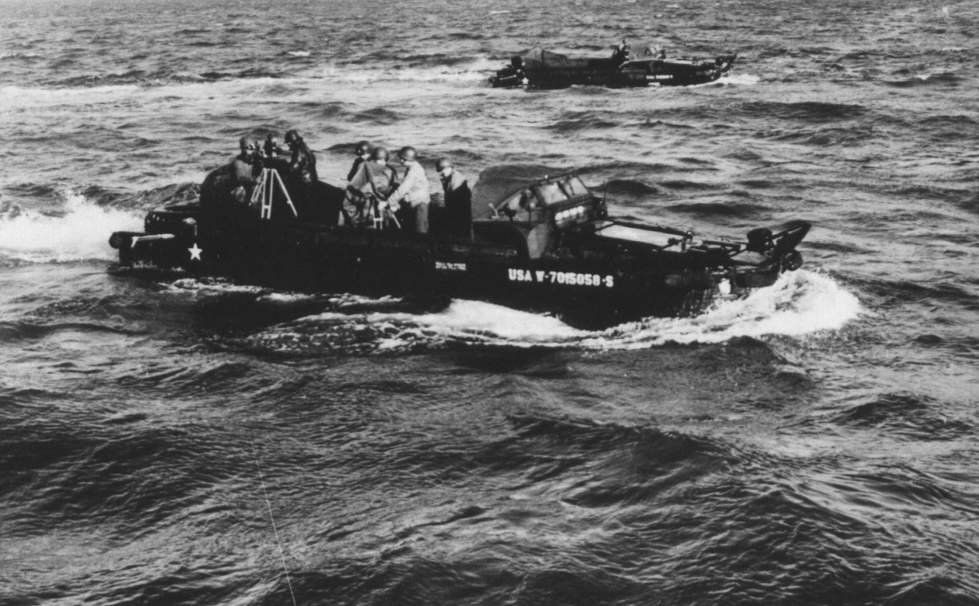
Do Not Talk To Me About The Sea and How Rough It Can Be! The Guys That Rode These DUCKS Were Real Army Sailors. That’s Me, George Hebenstreit, With My Movie Camera Shooting Footage to be Included in the Movie “YANK IN BRITAIN”. Yes it was miserable, wet and cold, January 1944. We were shooting the shoreline of Infantry storming the beach. Others in the movie “Yank In Britain: were, Burgerss Meridith, Jeffry Lynn and Robert Donat. Thanks to all aboard, they held me securely so I would not fall overboard.
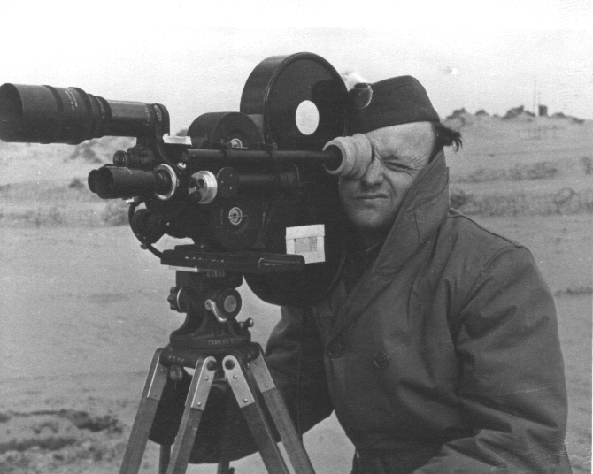
Shooting on the Beach in England, “Yank in Britain” during actual filming

