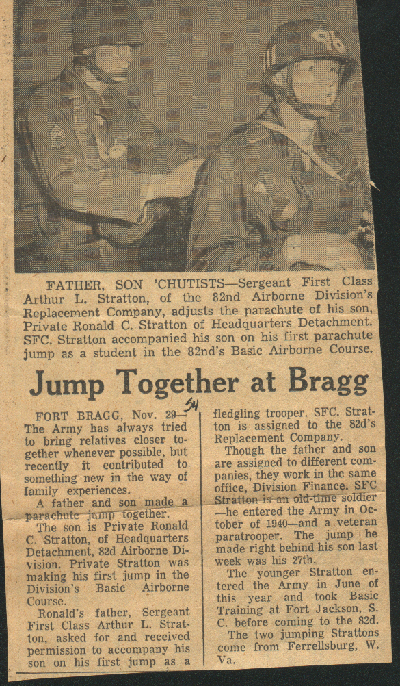
Ronald C. Stratton and his Father, 82nd Abn. Div. Jump School,
Fort Bragg NC, 29 November 1954

