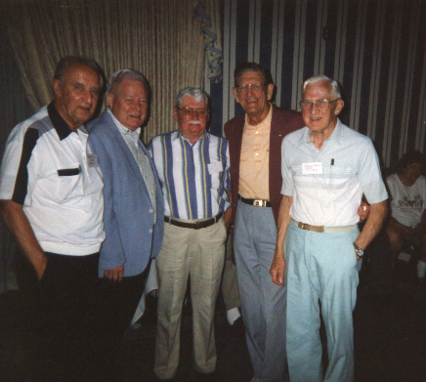
George Bodner, Elbert Legg, William Wasley, Charles D. Butte, Robert Ferrell

