Operation Market Garden
by Hans van Winkelhoff
http://www.panzerworld.net/marketgarden.html

Introduction
After the losses on the East front summer 1944, the defeat in Normandy and the losses after crossing the Seine, the Germans did not have the time to compensate the losses of the Panzer divisions. So they hastily formed 10 Panzerbrigades. These were sent to dangerous area's where an allied breakthrough was expected. Half of Panther production of August 1944 was for these brigades. One of these Panzerbrigades was the 107th. In the beginning of August it was formed out of remnants of the 25e Panzergrenadierdivision. It was stationed in Millau, East Prussia and underwent a short training time. The commander was Major Freiherr von Mahltzahn. The Brigade received 33 new Panthers and 12 STU IV's. All Panzergrenadeers and Pioneers were transported in Schützenpanzerwagen. There were 100 of these vehicles equipped with flamethrowers, mortars, 75 mm. kanons and heavy machine guns. So a high degree of mobility and a tremendous fire power! The brigades were sent hastily to the front. 107th Panzerbrigade was not trained enough and the Panthers did not even have their insignia's and markings and numbers! Furthermore, the brigade was meant to be sent to the East front and not to the West! But, the situation in the West was alarming. 4 Brigades were sent to Elzas Lotharingen and 2 to the area of Aachen. At the very last moment, 107th Panzerbrigade was sent to Venlo, Holland, because of Market Garden.

Note: For easier reference, refer to these maps:
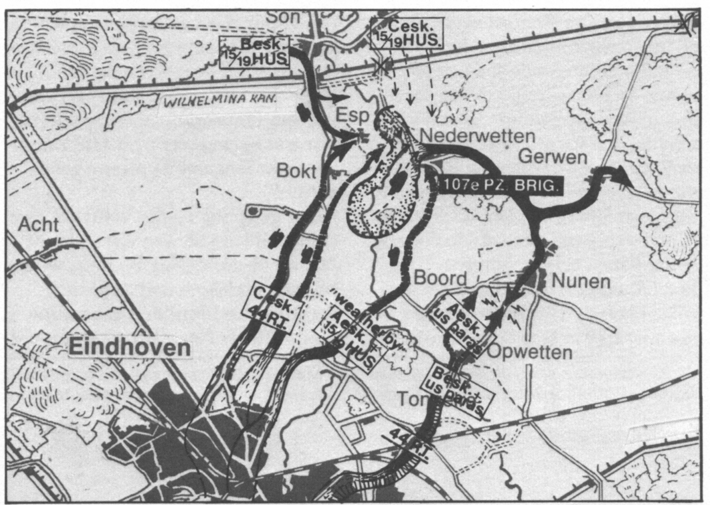
Map 1
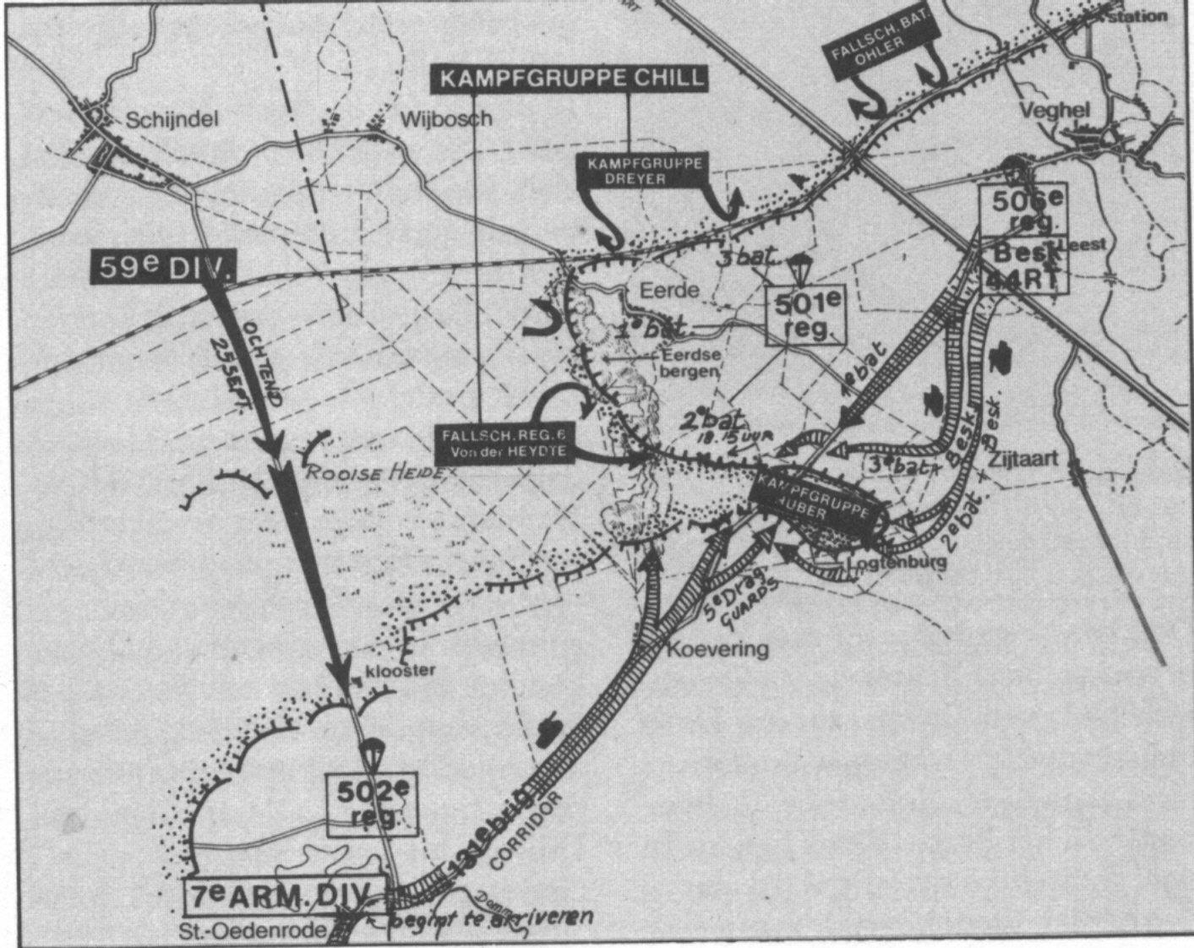
Map 2 – Veghel
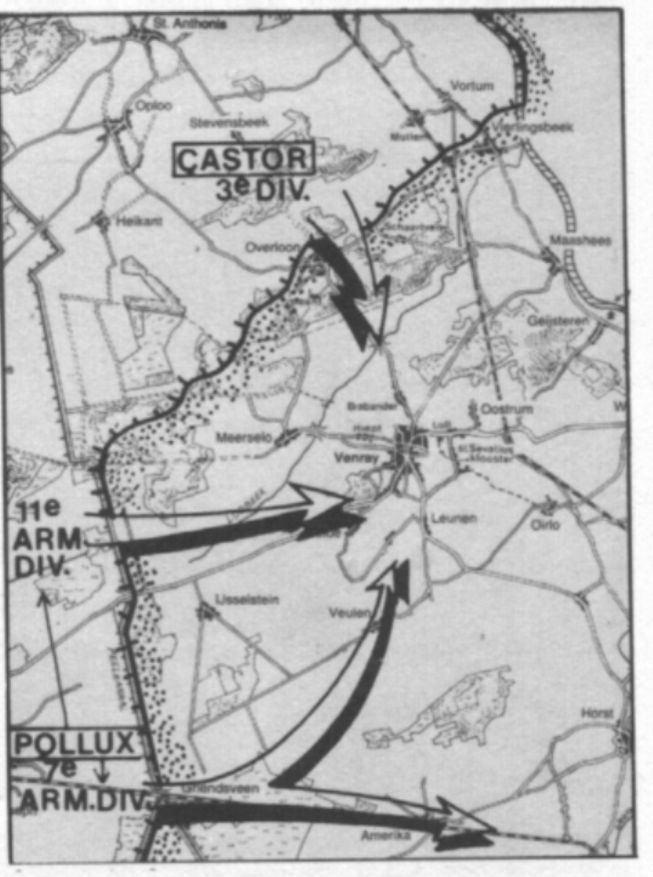
Map 3 - Constellation overview
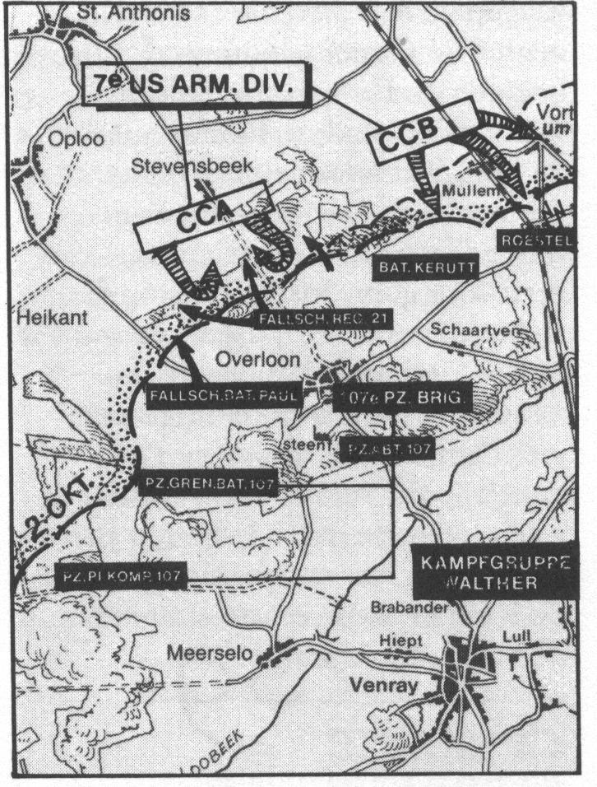
Map 4 – Overloon

Monday 18 September Market Garden
17 long militairy trains stopped at the railway station in Venlo. Von Mahltzahn stepped out and looked around. Where is everybody? Silence everywhere. There was a general strike that day and all the railway personnel had stayed at home. He went with his Kübel to castle Hillenraad near Roermond. He met overst von Wissmann, chief staf 86th corps. He promised von Mahltzahn that the brigade would be supplied with fuel and sent into battle as a whole and not in pieces. Okay, that was a relief for von Mahltzahn. His worries were understandable, because the situation around Eindhoven was alarming and his brigade was urgently needed, but the unloading took a lot of time. So, 86th corps had to wait for his brigade to be completely unloaded. Soon after his meeting with von Wissmann, the commander of 86th. corps, general von Obstfelder, phoned von Mahltzahn and ordered him to advance to Eindhoven immediately. Von Mahltzahn was furious. What a stupidity! Only a few Panthers and half tracks were unloaded and his brigade would be shattered bit by bit. He demanded delay. Okay, okay, you get your delay. In the meantime, unloading went one but now and then, allied airplanes and the unloading was stopped at such a moment. So unloading went slowly. In the evening von Wissmann phoned again and this time Student himself ordered von Mahltzahn to advance to Eindhoven. No discussion was possible. Von Mahltzahn understood this. The village Son was the target because the road to Nijmegen went right through it and the bridge over the Wilhelmina channel was of key importance. Reach it, take it and hold it! In Helmond 21 Fallschirmjägerbataillon under command of Hauptman Vosshage was waiting to reinforce the Panzerbrigade.

Tuesday 19 September
In the early morning the engines of the Panthers, some STU's and the half tracks were started and off they went. It was only a part of the brigade that was ready. So unloading went on. It was a very peaceful morning, a bit hazy, and the rural landscape was very nice: little villages, farms, pastures, birds were singing. War seemed to be far away. What a contrast! Soon the people were surprised by the sound of tank engines and the fearsome Panthers. This time the Germans did not go in direction Germany with stolen bikes, stolen pigs, barefoot, in haste and terrified, but they went direction liberators, to Eindhoven! And look what they have: tanks, half tracks, guns! In Helmond there was a break and the Fallschirmjäger climbed on the Panther tanks to get a ride. In the afternoon the brigade arrived in Nuenen, the village of Vincent van Gogh. It had been a nice ride, no problem. People in Nuenen realised that the war had come once again. German soldiers were hungry and knocked on the doors to demand food and drink.
In the meanwhile, operation Market Garden was not going well. Crossing the Dutch border from Belgium, the Guards tank division of British second army, had a heavy fight with Germans troops along the way to Eindhoven. In no time, 9 Shermans were knocked out by Panzerfauste, 75 mm.PAK and some STU' s. It costed time. The Guards reached Valkenswaard (south of Eindhoven) and took a break that evening. That costed precious time. Next morning there was a delay in the south of Eindhoven: the so called Riegel stellung consisting of some 88 mm. guns stopped the complete XXX corps for several hours. Why did the para's of 101 airborne not help? They had liberated Eindhoven and have had radio contact with the British of the XXX corps. Nobody knows up till now why they did so little. During the 19th of september there was some progress. A new Bailey bridge was built in Son and tanks and trucks of XXX corps were crossing it and went to the north, to Nijmegen and Arnhem where Urquharts para's were in trouble fighting Dutch SS troops, young Germans of a training Bataillon under Major Sepp Krafft and last but not least: the hardenened, experienced SS men of 9th and 10th Panzerdivisionen Hohenstaufen and Frundsberg, forming the 2 Panzercorps under General Bittrich. These were real professionals with East front experience and they had also undergone the hell in Normandy. The bridge in Son over the Wilhelminachannel was of great importance for second army. Then there was a quick advance suddenly: 15 km. in one hour! The British tanks reached Grave near Nijmegen and made contact with 82th. paradivision. But then, they halted because of 10th SS tank division and the bridge over the river Waal that had to be crossed.

The city of Eindhoven was in joy that 19th september. The Germans were gone and the Americans and British were kissed all over by the Dutch girls. All very nice, but the streets were crowded and it took time and time and there was a lot of army traffic. That next night a disaster: the Germans attacked Eindhoven with bombers. A complete surprise! This was not blind revenge, but a very tactical decision: the ruins would give the second army only more trouble to find its way to the north to Nijmegen and Arnhem.

The attack
The Germans near Son were fighting the American para's of 101th paradivision. They were told that a new German tank unit would attack from the east. But nothing had happened. The German general Poppe who commanded 59th infantry division, was disappointed. His division only had attacked and had lost 1700 men as prisoners. No wonder, the British had come with their Cromwell tanks. But where are our Panthers? In the afternoon of 19th september von Mahltzahn studied the map. He commanded his tanks to advance to the bridge in Son. There were several possibilities to reach the bridge, but he decided to use the channel dike. It was very difficult for the tank drivers to maneuver over that small dike, but there was no choice. The commander of this group of Panther tanks was lieutenant Brockdorff - Ahlefeld. Through his binoculars he saw tanks, trucks on the road to Nijmegen. He also saw British soldiers smoking cigarettes, sitting on the ground, drinking a cup of tea. No one had noticed the Panthers! Incredible. A completele surprise. Vorwärts männer! One by one the Panthers turned left. On their right there was the Wilhelmina channel and on their left there were trees and bushes. They were driving on the dike and there was no protection, no turning back and no choice. A real risk. It is 17.00 hour afternoon.

General Taylor, commander 101th Airborne, had heard rumours about German tanks advancing to Son. He was worried and sent a reconaissance platoon under command of Lieutenant colonel Moore. These men walked over the dike and there was nothing at hand. Suddenly they heard dark engine sounds and suddenly they saw a German camouflaged Panther approaching from behind the trees, and behind it, they saw another one. They were scared to death. They ran in all directions and some of them jumped into the water of the channel. The Panther fired at the bridge and hit a truck. More Panthers suddenly came out of the blue and they fired at the houses on the other side of the channel. Panic all around! The Americans tried to stop the Panthers with bazooka's but they were not succesful. Taylors headquarter received several hits. Taylor himself mobilised a jeep and raced to the field where the gliders were unloaded. He found a 57 mm. anti tank gun and took it with him. Immediately it was positioned near the bridge and fired at the first Panther that had almost reached the bridge. It was a hit. What a luck. The Panther came to a halt and blocked the way for the other Panthers. The Germans could go nowhere. The second Panther was hit by a bazooka and catched fire. Brockdorff - Ahlefeld realised that he could do nothing with his Panthers anymore. They were sitting ducks. So he asked von Mahltzahn to sent the Panzergrenadiere forward under covering fire of the withdrawing Panthers. Von Mahltzahn said it was too late in the afternoon, soon it would be getting dark, and he was afraid that Son was heavily defended. It was not and he would have surely conquered the bridge if he had sent the Panzergrenadiere. The first attack of the Panzerbrigade was not succesful, but it had been a very narrow escape for the British and the Americans. That evening German bombers attacked Eindhoven. See above. The joy of the liberation was over and people were afraid that the Germans would come back.

Wednesday 20th September
This day the road from Eindhoven to Nijmegen got the name Hell's Highway. Why? Because the allied line was very narrow, only this road! And the Germans crossed that line more than once and it was really hard fighting. German soldiers attacked in the morning the road to Nijmegen. They attacked south of Son. They had very little cover and the Americans used their 75 mm. houwitsers. The German tanks and half tracks could hardly be used because of the wet and muddy fields. The Germans were not able to cut the lifeline of the allies, but they reached their goal: delay. All traffic on the road came to a halt and black clouds of vehicles being hit were seen from far distance. The British came with their Cromwells and found some diversion to attack the Germans. Several Cromwells were knocked out and some drove on a mine. The Germans fired the road to Nijmegen with Panthers and STU' s and the allies losses were heavy. The Germans also lost some tanks due to fuel shortage and they were counterattacked from several directions. They withdrew. The British attacked from Eindhoven and at 12.00 hour the Germans were driven back en they had lost 158 men. But the fighting took 5 hours and all traffic had come to a halt during that time. The British were numerical superior to the Germans and came with their 44th tankbataillon and their Hussar tankbataillon. They also had some Sextons. The small village Nederwetten was conquered and the Germans lost 2 Panthers and had to withdraw to Nuenen. The promise given to von Mahltzahn that he would receive fuel for his brigade was broken. He had lost 9 Panthers in total and some just because of fuel shortage.

The remaining of the Panzerbrigade was unloaded that morning and the brigade was at full strength now and massed together in Nuenen. From several directions the British attacked the Germans, but all attacks failed and one Sherman after another was destroyed by heavy German fire. The Germans had changed Nuenen in a festung and they were determined to hold it. But the British VIII corps made progress east of Eindhoven. Its 11 tankdivison reached the line Heeze - Someren and was nearly ready to attack the Panzerbrigade in its back.

On 21 september Dutch civilians told soldiers of American 506 pararegiment that the Germans had left Nuenen and were heading for Helmond. At 10.30 hour Nuenen and the area around was free of Germans. The tanks of the Hussars found no resistance at all. All Germans were gone! How come? The answer was given soon. At 16.00 hour everybody in Nuenen heard the rattling sound of tank tracks. Germans again? No, Shermans of the 23 bataillon Hussars 11 tankdivision. This division had liberated Geldrop and nearly attacked the Germans in the back. That evening civilians reported that German Panther tanks crossed the bridge over the Zuid Willemsvaart and disappeared in the dark. All bridges were blown up by the Germans.

The British and Americans would meet the 107 Panzerbrigade again. Soon. German attack on Hells Highway near Veghel 14 km. north of Son, the corridor was very narrow and field marshall Model, ordered a counter attack right there. The Germans had Kampfgruppe Walther available and, very important, the 107 panzerbrigade. Also a bataillon of 180th infantrydivision. On 22 september British reconaissance cars spotted 4 Panthers heading for the corridor near Veghel. At 12.00 hour the Panthers reached the corridor northeast of Veghel. That was that. Piece of cake. The corridor was cut off! But reinforcements were approaching to attack the Germans. At 12.15 506 regiment of 101 airborne arrived in Veghel and 327 regiment was on its way with six pounders anti tank guns. The Panthers of 107 Panzerbrigade were having fun destroying everything they met on their way. But a six pounder knocked out one Panther by hitting its track. The Germans were careful with their tanks the rest of the day. However, the situation was still dangerous. The Germans attacked again. From the east kampfgruppe Walther tried to reach Veghel with Panthers. They did not succeed and lost one Panther. The Germans fought desperately to cause as much delay as they could and they were succesful in that. 23 september they attacked again. Kampgruppe Walther attacked 2 bataillon of 501 regiment (101 airborne). It was raining and fighting was real heavy: men to men. Panthers knocked out several Shermans and a Firefly but also lost a Panther which was shot from behind. In that fight major von Plüskow, commander of the Panther abteilung, was killed. Kampfgruppe Walther withdrew. Another Panther was abandoned because of fuel shortage.

Kampgruppe Walther was threatened in the back and was no longer available for attacks on Hells Highway. Kampfgruppe Chill arrived together with the famous Fallschirmjäger regiment under command of colonel von der Heydte, a briljant officer. Kampfgruppe Huber was also available and not to forget: 4 Jagdpanthers of 559 Panzerjägerabteilung. The attack would be launched south west of Veghel 24 september. This was a crucial date for the allies. The situation in and around Arnhem was alarming. Market Garden was about to be a disaster. The Germans also knew that they had to risk everything to cut the corridor. So they took every possible risk and attacked again and again. The Fallschirmjäger ran into the American para’s of 501 regiment near Eerde. In that sandy area they fought man to man. The British came with Sherman tanks but three were knocked out by 88mm. guns and the remaining tanks left the battlefield. The American para’s launched a counterattack and slowly they pushed back the Fallschirmjäger. At 15.30 hour the dunes around Eerde were cleared of Germans. The Germans played their last card now. Further south they attacked with the four Jagdpanthers and a Fallschirmjäger bataillon under major Jungwirth. They reached the little village Coevering. At 17.00 hour the Fallschirmjäger cut off the corridor right there! There was panic. The British sent some Shermans to attack the Jagdpanthers that were destroying a group of trucks. One Jagdpanther knocked out 3 Shermans in no time. Next day (25th september) the Germans attacked again. Their goal was St. Oedenrode and they had 200 men and five STU’s. They also attacked again near Eerde. Both their attacks failed. The Americans counterattacked with 506 regiment and Shermans. They wanted to reach the corridor and drive away the Germans there. Jagdpanthers and STU’s knocked out Shermans near Logtenburg and the Germans also used two captured Shermans. The allied failed to free the corridor. Another day and opportunity was lost. Fortunately the Germans withdrew at night. They were afraid to be surrounded. The Jagdpanthers were used as artillery tractors for the 88 mm. guns. 26 September in the morning, British and Americans saw that the Germans were gone. But they were not beaten in any way! Fine, the corridor was free again. But for Market Garden it was too late. These German attacks at 24th september meant the definitive failure of Market Garden. All the reinforcements needed for the para’s at Nijmegen and Arnhem stayed behind in and around Eindhoven. Montgomery’s Market Garden had failed. He said it was succesful for 90% but the last 10 percent were essential! So it failed 100%! The allied lost 17.000 men, more then 100 tanks, 260 airplanes and 1400 airplanes were damaged. The Germans lost only 9000 men and 100 vehicles (tanks included).

Why did Market Garden fail? Several reasons:

- The allied underestimated the Germans. After the defeat in Normandy and the race to Germany, it could be expected that the Germans lost their morale. But in no time they organised a very effective defense and they just started fighting again. Hastily formed Kamfgruppen proved to be excellent units that were able to hold ground against numerically superior allied battle units. Weakened German units fought with a surprising courage and stubborness. This was totally unexpected. Some of these German units were from 15e armee that had escaped from west Belgium and reached the corridor from the west. They were on their way to Germany, the Heimat, and had to cross the corridor. The allied only had attention for the line Eindhoven – Arnhem and took not enough notice of this 15e armee under General von Zangen. Between 5 – 22 september 82000 German soldiers, 530 guns and 4600 vehicles crossed the river Schelde and started fighting. It was a real mistake the allied made. They willfully had ignored 15e armee and they payed the price for this.
- The weather was real bad now and then, but this was an argument used as a bit of a weak excuse by the allied themselves after the failure of Market Garden. Okay, there were rainy days, but there were also sunny days.
- The allied did not listen to the messages of the Dutch resistance that had given a warning: German tank troops of Hohenstaufen division had arrived near Arnhem. Montgomery did not want to hear this and ignored these signals.
- The British were too slow in their advance. They did not take initiative at crucial moments. They took a break in Valkenswaard and the complete XXX corps came to a halt when reaching Eindhoven because of a few 88 mm. canons. They lost the initiative. Precious time was lost, but the Germans knew how to use this time effectively.
- The landing areas for the American and British paradivisions were wrong chosen. As a result, it took too much time for these paratroopers to reach their objectives. The men of 1st Airborne had to walk 10 km. to reach the bridge over the Rhine!
- The use of one some single road starting from the Belgian Border and ending in Arnhem proved to be too risky. On paper Market Garden was a briljant plan and worth trying, but in practice it was just too ambitious. Market Garden failed not in and around Arnhem. What could these brave paratroopers do against heavily armed SS men with their half tracks, Sturmgeschütze, Panthers and their new King Tigers? Almost nothing. Market Garden was lost in the area Belgian/Dutch border – Nijmegen. Everything went wrong there. 1 paradivision in Arnhem paid the price.

What about 107e Panzerbrigade?
Kampfgruppe Walther (107 Panzerbrigade included) received order to go north east to form a new defense line from Boxmeer and around Overloon and Venray. This was the wet and muddy area of the Peel. The Allied did not expect much danger from this area. They underestimated the Germans and they would soon come to realise that. The Germans would show once again their ability to maintain even under the most frightening and stressing circumstances. This ability was born out of desperateness as they told after the war. The German soldiers had no choice and believed that allied victory over Germany meant only hardship, oppression and humiliation. Fortunately, this proved to be wrong. German propaganda.

Next we go to Overloon where the hardest fightings in 1944 on the westfront took place, similar to Monte Cassino and even harder than the fightings near St.Lo and around Caen a few months earlier.

Battle in the Peel: Overloon, Venraij and Meijel - Introduction Overloon
The area west of the river Maas is called “de Peel.” It is an area of woods, swamps, mud (esp. in autumn). There had fallen a lot of rain at the end of september, so traffic near the roads was impossible. The Germans took advantage of this situation and builded excellent defense lines and used mines in abundance. East of Helmond they had the 7th Fallschirmjäger division. Northly the 180 th inf.div. was situated. This was a bit of a weak division but the area was for tanks almost inaccesible because of the swamps. It was not likely that the Allies would attack there. Kampgruppe Walther defended the most important line near Venray. Germany was nearby, so…. This Kampgruppe was a patchwork of all kind of units but the morale was good and the quality of the troops also: SS Sturmgeschütze under major Roestel (Frundsberg division), Fallschirmjägerbataillons under major Kerutt and Hauptmann Paul. The Panthers of the 107e Panzerbrigade were in reserve.

This area came under responsibility of American 1st army (Hodges). The 7th armoured division (Hell on Wheels) was given from 3th army to 1st army. The commander of the allied forces in de Peel was general Corlett. Everbybody was optimistic: 7th armoured division would take Overloon and advance to Cologne as fast as possible together with 113 cavalry group and a Belgian tank brigade (Cromwell tanks). This optimism was understandable, because kampfgruppe Walther was numerically not so strong (one regiment). Should this unit be able to stop an American tank division, a Belgian tank brigade and a cavalry group? Of course not.

First battle: the Americans strike first
Commander of 7th armoured was Lindsay Silvester. He did not consider it necessary to waste time with reconaissance patrols. On 30 september combat commands and task forces of his division would attack Overloon and the area around. At 16.30 the engines were started and off they went. After a few minutes 88 mm. shells hit the leading Shermans and these were knocked out. These Shermans could not be passed because leaving the road was impossible: the tanks would be immobilised in the mud. The American infantry could not proceed either because of fierce German fire. 1 october the Americans tried again. It was rainy. The SS troops under Major Roestel fought like lions and the combat command under brigadegeneral Hasbrouck was stuck. At the height of Overloon the combat command under brigade - general Rosenbaum engaged the Fallschirmjäger under hauptmann Paul. Shermans came into a minefield and were there under fire of Panthers and 88mm. canons. This day was another failure.

Next day, 2 october, the American attack was better prepared. Six British artillery bataillons had arrived. 1500 grenades came down on the Germans. The first lines were taken, but Overloon remained in hands of the Germans. Suddenly the Fallschirmjäger attacked with an unbelievable fighting spirit and with much effort the Americans could stop them.

Silvesters attacks were all failures so far. He had just one more chance: he ordered combat command R under colonel Ryan to come into action in the area where Roestels SS men had dig themselves in. Ryan attacked 3 october in the afternoon, but immediately the Germans reacted with Panzerfauste, PAK’s, machinegun fire and with their Sturmgeschütze. The Americans could hardly believe what had happened. The Germans had tremendous firepower, courage and fighting spirit.

5 october was the ultimate chance. Lieutenant colonel Wemple tried with his Task Force to reach Overloon from the east. There was some open terrain and this was a possibility for the tanks to take advantage of their mobility. The first actions were promising. The tanks were very near Overloon but suddenly 88mm. guns opened fire. In no time 13 Shermans were knocked out. Wemple asked for air support and he got it. The little castle de Hattert was a ruin after the bombardments.

Evaluation: in six days all attacks had been disastrous. The strength and the will of the Germans to fight fanatically had been a complete surprise. The Americans had really underestimated the Germans. It was a big mistake to decide that reconaissance patrols were not necessary. 35 Shermans were lost and more than 450 men were killed or wounded and with decisive counter attacks the Germans threw the Americans back. The Belgian tankbrigade and the 113 Cavalry group also failed completely in their efforts to advance. They had expected that de Peel would be a piece of cake. But the time of racing through France with direction Germany was over. They had not realised that. Morale was low after Overloon. 7th armoured left the battlefield with its head down.

Now the British! - Introduction
British 3 division under command of General Whistler was to attack Overloon at 12 october. This attack was part of a bigger plan with the objective to reach the river Maas and clear up the German bridgehead in the Peel. British 8th corps was to do this job and was reinforced with Scottish 15th division. To the south 11th armoured and 7th armoured would attack in the direction of Venray. Code name: operation Constellation (sub code names Castor, Pollux, Sirius, Vega. This is something for the astronomers under us).
What did the Germans do? They gave Kerrut’s bataillon a time of rest and it was taken away from the frontline. The Fallschirmjäger of Hauptmann Paul were the only German soldiers to defend the woods around Overloon. Another bataillon of Fallschirmjäger came to reinforce Hauptmann Paul’s bataillon. The SS unit under Sturmbannführer Roestel was also taken away from the frontline and was given back to 10th SS tank division. Instead another para unit came to this part of the front: Fallschirmjägerlehrregiment under Oberstleutnant Herrmann.

Circumstances were miserable. It was a desolate part of Holland. It rained and rained and there was mud everywhere. The battlefield and the circumstances reminded of the trenches of World War I.

The plan
The British made very accurate plans. Everything was well organised and planned. No more amateurism and adventures! After an artillery bombardment, two infantry bataillons would slowly advance under the protection of ongoing artillery fire. At the same moment American bombers were to bomb Venray to make it impossible for the Germans to withdraw over the river Maas or to send for reinforcements. The infantry was supported by flail tanks that would clear the minefields and by two bataillons Churchill tanks of 6th Guards tankbrigade. At 11 october no rain fell. It was very silent everywhere. Soon that silence would be over.

The attack
Thursday 12 october there was a lot of activity behind the British frontline. The infantry was brought to the Stevenbeekse Bossen in trucks. The engines of the Churchills were started. Somewhere else (near Oploo and St. Anthonis) a lot of guns were prepared for the bombardment: two hundred sixteen 25 pounders and sixty eight heavier guns. The gunners waited for the order to fire. At exactly 11 o’clock in the morning hell broke loose. The sixty eight big guns started firing and after half an hour the 25 pounders followed. The bombardment lasted for one and a half hour. Overloon was blast away and more then one hundred thousand shells were fired. It seemed impossible that a human being could be able to survive this inferno. Who would survive would not be able to fight. The infantry went forward in three groups: one group straight to Overloon and the other two groups to the north and the south of the village. The artillery kept on firing and the Churchills followed the infantry, ready to stand by. In one hour the men advanced one and a half kilometer. Slowly, yes, but without real problems. All went well. Then fighting real began. The East Yorks bataillon tried to take the wood north of Overloon. German Fallschirmjäger started fighting. Unbelievable! There had been a terrible artillery bombardment and the British left nothing to coincidence, but still there were Germans able to fight and resist. Churchill tanks were knocked out by PAK’s. The losses of the East Yorks were incredibly high. There was a corporal who was ordered to command a company because all the officers of higher rank were killed or wounded.

In the center the Suffolks were in trouble. Churchills were knocked out by Panthers of 107e Panzerbrigade, but the stone factory south of Overloon was reached and taken. When it was getting dark, the British stopped the attacks.

More to the south the South Lancashire bataillon tried to advance. Churchills drove on mines and the bottomplates were gone.

The three infantry bataillons had reached their objectives for that day and Overloon (although it was transformed in a ruin) was conquered for the biggest part. Nevertheless, considering the tremendous preparations, the enormous artillery fire and the efforts, the result of this day was meagre.

Next day it was Friday the thirteenth. What would this day bring? 185 brigade was sent into action. Six bataillons stood ready to attack the Germans. Very slowly the British gained ground, but the losses were high. In the woods around there was bitter fighting. The Fallschirmjäger fought for every inch of ground and they tied themselves up in the trees and were willing to go on fighting till death followed. When the Germans ran out of ammunition they went on fighting with spades and bajonets till death followed. There were no Prisoners of War, because hardly any German soldier surrended. The Germans fired the fearsome Nebelwerfer (Moaning Minnies) and several Churchills were lost because of mines, PAK’s, Nebelwerfer and German tank fire.

On this day, 13 october, the Panther number 222 that is restorated at present in the War Museum Overloon, was knocked out by men of the East Yorks bataillon. A PIAT grenade hit the Panther in the track. No Prisoners of War. The German crew was killed by machinegun fire of the British. No mercy. A complete difference with the fights in and around Arnhem the month before. These were the hardest, toughest fightings at the West front during 1944 –’45. Only massive shelling, heavy artillery firing, a phenomenal firepower altogether and methodical attacking under cover of Churchill tanks with a numerical superiority, brought succes. The British left nothing to coincidence. The Americans often talked of the slow and careful British and showed off with their courage and skill and speed (the Patton way of warfare), but for this job the British approach was needed. The American approach had utterly failed a few weeks earlier.

Venraij
Next day Friday the thirteenth was over, but what would the next day bring? The British started to advance to the Loobeek, a rather small stream that had to be crossed to reach the city Venray.

Roestel with its SS bataillon was replaced by the Fallschirmjâgerlehrregiment under Löytved – Hardegg. 107e Panzerbrigade was kept in reserve. The remnant of Bataillon Paul was withdrawn. The Fallschirmjäger had done what they had to do: maintain to the utmost.

On the road Overloon – Venray tanks of the 1st. Royal Norfolk were heading for Venray and they reached the Loobeek. Unfortunately the Churchills ran into three Panthers. In a short moment, four Churchills were knocked out.
South of Overloon, where the South Lancashires tried to advance further, the Grenadier Guards lost three Churchills.

But nevertheless, the area of Overloon was in the hands of the British. They had achieved what American 7th armoured had not achieved: take Overloon and hold it. The price was high and the efforts tremendous. It had been first World War fighting. The British lost 1400 men.

16 october the British tried to cross the Loobeek to reach Venray. The tanks of the Coldstream Guards were immobilised in the mud and a German 88 mm. started shelling these tanks. A Churchill Pontoon Bridge Layer was sent for, but fell aside in the mud. Instead of those bridge layer Churchills 8th Brigade came with so called Fascines: Churchills with huge packages of tree branches on the engine decks. One of these Fascines got stuck in the mud, another one stayed behind in the Loobeek and another one was knocked out because the branches caught fire. Some units however succeeded in crossing the Loobeek and could reach the outskirts of Venray. General Whistler had four bataillons now around Venray. Next day the last phase of operation Constellation had to start and Venray was the objective of the allied. British 11th and American 7th armoured division attacked from the south.

17 october was a rather good day for the allies. There was hard fighting here and there, but the British had good tank support and half of Venraij was under control by the British troops at the end of the day. So it seemed that the Germans really have had some severe blows and were licking their wounds. In reality they were not beaten at all, but they were withdrawing and regrouping their units to secure effective defense lines.

19 october 180 th German division launched a completely unexpected counter attack south of Venraij near the village Veulen. The British troops could hold their positions, but not without hard fighting. 7th armoured division tried to reach Venlo but got stuck in the mud. A lot of American soldiers suffered from trench oedemia and could not walk anymore.

The Germans were still in control. A British intelligence report dated 22 october praised the German morale and discipline. For the British infantry soldiers it was a nightmare, fighting in the cold and wet area of the Peel in october against the Germans.

Meijel: the last attack
The village of Meijel was abandoned. The inhabitants were gone and most of the houses were ruins. Two Americans guards walked through the village. Suddenly they simultaneously turned their heads. They heard some metal sound. In the dark they saw vaguely a few men preparing a machine gun on a tripod. The Americans opened fire and the enemies disappeared. Again German patrol units had infiltrated the American front lines and appeared in Meijel. These Germans were looking for weak spots in the American lines. Meijel was a weak spot. It is difficult to grasp how the Americans of 7 armoured division could still be so careless after their defeat in the Peel. Okay, there were swamps and a few channels around Meijel, but trusting on this natural defence and consider yourself save by this, would be a mistake. The American defense was thin there, but all was quiet and the Americans didn’t worry too much. The arrival of an American Jeep in a British army quarter illustrates this careless attitude: the driver has a cigar in his mouth (just like tough John Wayne) , he is steering and has his foot on the clutch and the officer next to him has chewing gum in his mouth and has his hand on the gear box lever. Completely in style he has his right leg hanging out of the Jeep.

Oberbefehlshaber Heeresgruppe B Model heard of the weak American defense in and around Meijel. He decided to attack there. If this attack could be a succes the allied would be forced to sent troops to this front sector and pressure on 15e armee in the western part of southern Holland would be relieved. Von Rundstedt gave Model permission for this attack. Okay, but now Model had to search for a division or Kampgruppe. 47e Panzercorps was taken out of battle to be reinforced. Its commander was general von Luttwitz. This corps consisted of 9e panzerdivision and 15e panzergrenadierdivision. In total 25000 men and 9e panzerdivision had 22 Panther tanks en some 30 Sturmgeschütze. 107e Panzerbrigade stayed around Venray in reserve. The Germans wanted to reach the village Asten. That was all.

Unnoticed by the Americans the Germans took their positions. 27 october they attacked!

The attack
The sight was very limited, because of the morning fog. The night had been quiet and the Germans had sent no patrols. At 6 hour 15 the German artillery started firing for fourty minutes. Soon the German troops attacked. They knew exactly what to do, there was no delay, no hesitation and quickly they advanced with the Panthers and the Sturmgeschütze. At 8 hour Meijel was in German hands. American tanks attempted to stop the Panzers but six of them were killed instantly. The Germans builded bridges over the Kanaal naar Deurne (channel to Deurne). At 11 hour the Germans crossed that bridge. The fastness of the German advance was amazing. General Silvester of 7th armoured sent reinforcements to Asten and Heitrak. One kilometer west of Asten the Germans and Americans ran into each other and there was a hard fight. The Germans won but the Americans under command of lieutenant – colonel Chappuis could hold ground.

General Silvester asked for help by British 8th corps. General o’Connor gave him an artillery unit and the British 11th armoured would come to help.

Next day both Americans and Germans attacked again and there was real hard fighting once more. 15 Panzergrenadierdivision ran into Combat Command Hasbrouck and killed 13 Shermans. The other American attack near Hoge Brug was also a failure with heavy losses for the Americans. As if this was not enough, the Germans launched a strong counter attack. The Germans also attacked south of Asten where Task Force Chappuis was situated and Chappuis could forget his own attack. In the south German Fallschirmjäger attacked task force Nelson and they took the village Ospel.

The situation became real critical for the allied. A German breakthrough was at hand! The Luftwaffe came in action and bombarded Helmond which was not far from the frontline. Everyone was scared that the Germans would take Helmond.

Montgomery had been optimistic before the German counterattack and was planning an attack out of Nijmegen to the Reichswald. He could forget this whole thing. He realised the extreme dangerous situation. Luckily Scottish 15 division had just liberated the city Tilburg west of Eindhoven. Also 6th Guards tankbrigade was suddenly available for a new task.

29 october the British artillery that had arrived was a real help for the American defense along the way Asten – Meijel. M 10 tank destroyers attacked a German reconaissance platoon of 9e panzerdivision and the Germans had to stop their attack at Asten.

The American soldier that stood guard south of Liessel heard the sound of heavy engines and he thought of British tanks. These were Panther tanks! Because of their wide tracks the Panthers were able to run through the mud without getting immobilised. The Americans were completely surprised and the Germans took Liessel with 200 Panzergrenadiere and Panthers tanks. Now the situation was so alarming that the Germans had to be stopped by all means.

The Scottish 15 division was complete by now at 29 october. Now the gap between Asten and Liessel could be filled up. 44 Brigade was chosen for this task. Now Asten was defended everywhere and all gaps were closed. A real relieve for General Barber, commander of 15 division. The first crisis was over.

29 and 30 october the Grenadier Guards and Coldstream Guards arrived. Time for the counterattack!

But first the Germans attacked once again. Model got permission from von Rundstedt for one last attack within 24 hours. 30 october the Germans from Liessel in the direction of Asten. The Glasgow Highlanders had to face Panzer IV tanks and Sturmgeschütze. A breakthrough to Asten was unavoidable, but the tanks of the Grenadier Guards reached the Scottish bataillon and the Germans advance came to a halt definitely.

30 october Bradley fired General Silvester as commander of 7 armoured division and was replaced by Hasbrouck.

At last the allied counterattack could start on 31 october. The Germans pulled back slowly but they fought hard. On 2 november the 15 division started the attack on Meijel. Several Churchill tanks were lost because of mines and Sturmgeschütze and PAK’s. It was impossible to take Meijel and the 15 division took a rest. After a week there would be a big offensive (operation Nutcracker) of British 2 army (12 and 8 corps) and Barber decided to wait for that. 13 november the Germans gave up Meijel. They just left the city in silence. Slow but sure the Germans were pushed back to the east in the month November. The rain and mud were terrible, both for allies and Germans. In december the Germans crossed the river Maas after they had given up their three bridgeheads Broekhuizen, Blerick and Geijsteren. Kasteel Geijsteren was shot to peaces by Churchills with 95 mm. guns and a captured Panther of 107e Panzerbrigade nicknamed Cuckoo. The demolition of this castle was unnecessary.

In December the Germans attacked in the Ardennes. This was their last gamble.

Conclusion
The crusade that started in Normandy in the summer and had its climax in sunny august ended in the cold, in the rain and mist and mud in Holland. It was a nightmare for the allied soldiers. They could not be home at Christmas. The Germans were not defeated. Far from that. They not only were fully able to succesfully defend their frontlines in the Peel, but they were also able to launch powerful counter attacks that surprised the allied completely. So the German offensive in the Ardennes was preceded by several German counter attacks in Holland. These problems the allied were confronted with, were a logical result of the failure of Market Garden. German 15e armee was able to escape from Flanders and the south west of Holland to the east. The units of this German bound strong allied forces. It took three months to wipe the Germans out of the south of Holland and to make use of the port of Antwerpen. Reaching the river Maas was an unbelievable difficult job and the Germans, not the allied, determined time and place.

St.Lo, Caen, Bastogne are famous battle grounds. But the hardest fighting, the greatest suffering, the most fanatical resistance of German troops was in the Peel, especially in and around Overloon. The fighting there is comparable with the tremendous fighting of German Fallschirmjäger at Monte Cassino. In Overloon the heart of the defense was formed by Fallschirmjäger again.

Most of allied veterans wanted to forget these memories. There were no glorious victories to celebrate, everything was dark, wet, misty and sickening. There was no Bastogne in the Peel. The Germans were more succesful than the allied and only lost ground when they decided to draw back. That’s why the battle in the Peel is hardly mentioned in American and British war history writings.

What happened to 107e Panzerbrigade? It was dissolved and the remnants were used to form a new 25e Panzergrenadierdivision. Funny, 107e Panzerbrigade was formed out of the remnants of 25e Panzergrenadierdivision and now on its turn contributed to the formation of this unit.

Source
Einddoel Maas; Jack Didden & Maarten Swarts

Page Details
Page title: Operation Market Garden - article by Hans van Winkelhoff
URL: http://www.panzerworld.net/marketgarden.html
This page was last updated: tuesday, 27 April 2004
Have a question or comment? Send me an e-mail at panzer@panzerworld.net

