The actual grid map will eventually replace this one. All text in red is not yet revised.
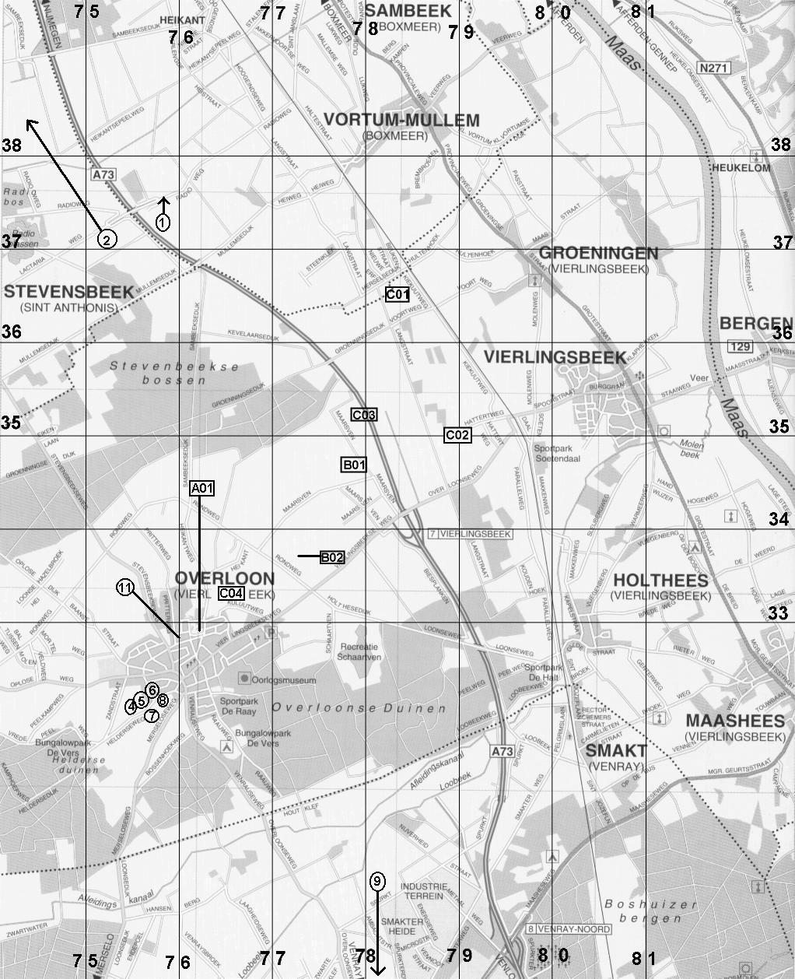
38th Armored Infantry Battalion (and some other) Bodies Found in Overloon Area
38 AIB Company “A”
A01 – Epstein, (5 Oct)
38 AIB Company “B”
B01 – Blankenship (7 Oct)
B02* – Bradley, Critser, Lyman (7 Oct)
38 AIB Company “C”
C01 – Gutierrez, Jacob (4 Oct)
C02 – Haney (4 Oct)
C03* – Robbins (4 Oct)
C04 – Baldwin (4 Oct)
Others
1 – Shints
2 – Paxton, 23 AIB (8 Oct)
4 – Dysinger, 48 AIB
5 – Kuykendall, 48 AIB
6 – Unknown T-1901
7 – Burt, 48 AIB
8 – Grounds
9 – Gogall/Dogall – There is a Cpl. Thomas P. Gogal 33622882 (680th Field Artillery Battalion, 17th Airborne Division) who died 24 Marcy 1945 and is buried at Margraten.
11 – Unknown T-1741
(* = Location uncertain)
Details
Uncertain Locations
- The location of B02 is uncertain. The location of B02 on this map is based on the alternate coordinates 776-335 in Bradley’s IDPF. Since they were not recovered until 1946, the coordinates (8035) on the map in their IDPF are not correct: that is the town of Vierlingsbeek. They were clearly buried in open fields and not in a town. Critser’s records say that he was found in an open field on the land of M. Achten. Bradley and Lyman were across the road from Critser, on the land of S. J. Groot.
- The location of C03 is based solely on coordinates (779-353), since there was no map.

Ref | ASN | Surname | First | Mid | Rank | Unit | Date of Death | Cause of Death | Reburial | Home Town | Wife / Kids | Buried
A01 | 33 749 676 | Epstein | Myer | (NMI) | Pvt. | A | 5-Oct-1944 | SFW Head | 18-Jul-1945 | Washington, DC | Yes/Yes | Arlington
B01 | 33 652 284 | Blankenship | Paul | Grey | Pvt. | B | 7-Oct-1944 | Unknown | 19-Nov-1959 | Christiansburg, VA | No/No | Margraten
B02 | 35 111 443 | Critser | Andrew | F. | Pfc. | B | 7-Oct-1944 | Head wounds | 12-Apr-1946 | Lapel, IN | No/No | Lapel, IN
B02 | 35 073 701 | Bradley | Morris | B. | Pvt. | B | 7-Oct-1944 | Shrapnel wounds in stomach | 12-Apr-1946 | Winchester, KY | Yes/No | Ardennes
B02 | 38 076 527 | Lyman | Harlin | H. | Sgt. | B | 7-Oct-1944 | GSW | 12-Apr-1946 | Fleming (& Sterling), CO | Yes/No | Ardennes
C01 | 38 583 229 | Gutierrez | Luis | (NMI) | Pvt. | C | 4-Oct-1944 | Unknown | 2-Mar-1945 | Vaughn, NM | Yes/Yes | Margraten
C01 | 31 329 105 | Jacob | Robert | J. | S/Sgt. | C | 4-Oct-1944 | Unknown | 2-Mar-1945 | Stratford, CT | No/No | Bridgeport, CT
C02 | 20 846 940 | Haney | Henry | M. | T/Sgt. | C | 4-Oct-1944 | Hole in back blowing out front of chest | 23-Jul-1947 | Yuma, AZ (& Philadelphia, MS) | No/No | Ardennes
C03 | 37 691 965 | Robbins | William | R. | Pvt. | C | 4-Oct-1944 | Unknown | 16-Apr-1945 | Cincinnati, IA | Yes/Yes | Cincinnati, IA
C04 | 33 529 694 | Baldwin | James | D. | Sgt. | C | 4-Oct-1944 | Unknown | 14-Jul-1945 | Roanoke, VA | No/No | Margraten
1 | ? | Shints | George | F.? | ? | ? | ? | ? | ? | ? | ? | USA
2 | 37 736 701 | Paxton | Harry | M. | Pvt. | 23 | 8-Oct-1944 | ? | ? | ??, ID | ? | Margraten
4 | ? | Dysinger | John | M., Jr. | ? | 48 | ? | ? | ? | ? | ? | USA
5 | ? | Kuykendall | Bennie | J. | ? | 48 | ? | ? | ? | ? | ? | USA
6 | ? | ?? T-1901 | ? | ? | ? | ? | ? | ? | ? | ? | ? | ?
7 | ? | Burt | Egbert | L. | ? | 48 | ? | ? | ? | ? | ? | USA
8 | ? | Grounds | W. | R. | Lt. | ? | ? | ? | ? | ? | ? | USA
9 | ? | ?Goodall? (given as GOGALL) | ? | ? | ? | ? | ? | ? | ? | ? | ? | ?
11 | ? | ?? T-1741 | ? | ? | ? | ? | ? | ? | ? | ? | ? | ?

