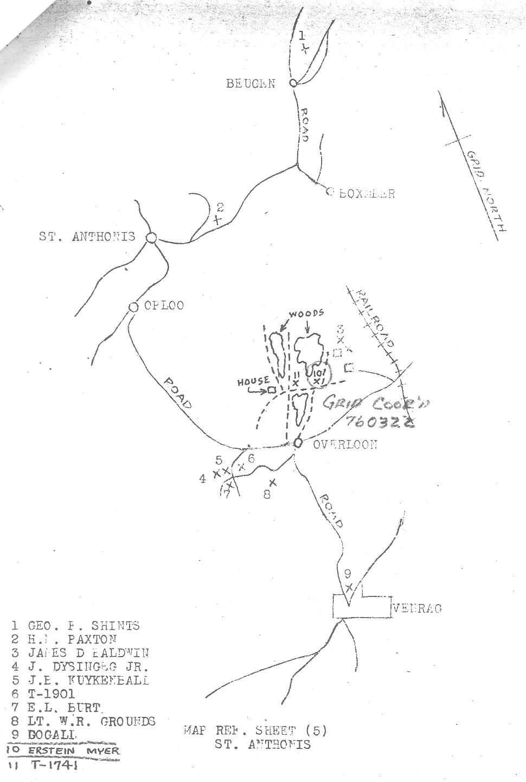
11 Bodies Found at and near Overloon
Research by Wesley Johnston, as of 1 September 2010
[Uncertain letters are in brackets. Red are still puzzles.]
1. George F. Shirts – Nose Gun 509BS, 351BG, 22 Jan 45, 17136758, McDaniel Cem; Cameron, Missouri
2. Harry M. Paxton –B/23 AIB, 8 Oct 44, 37 736 701, Margraten
3. James D. Baldwin – C/38 AIB, 4 Oct 44, 33 529 694, Margraten (was originally T-1902)
4. John M. Dysinger, Jr. – C/48 AIB, 5 Oct 44, 33 511 339, USA cemetery not yet known
5. Bennie J. Kuykendall: AT?/C/48 AIB, 4 Oct 44, 38516376, Liberty Cem; Stamps, Arkansas
6. S/Sgt Joseph J. Ferrari – C/48 AIB, 3 Oct 1944 (official 5 Oct), Margraten (T-1901, later X-1212)
7. Egbert L. Burt: C/48 AIB, 5 Oct 44, 38399612, Oak Park Cem; Chandler, Oklahoma
8. 1st Lt. William R. Grounds – Pilot 389FS, 366FG, 0-809129, USA cemetery not yet known
9. DOGALI./DOGALL – not on WWII Registry nor on 7AD list with either spelling – probably airman
10. Myer Epstein: A/38 AIB, 5 Oct 44, 33 749 676, Arlington National Cem
11. T-1741 – Unknown to British and given to American Graves Registration for recovery
Thanks to Joost Evertsen for the identifications of #1 and #6.

