Kamphoefweg 5 October 1944 C/48 Deaths Maps

**by Wesley Johnston, Historian, 7th Armored Division Association**

**August 7, 2010**

This document contains all of the maps of remains recoveries that I have thus far received in Individual Deceased Personnel Files.

# Contents

1. Joseph Ferrari – C/48 – KIA 5 Oct 1944 – Recovered 13 July 1945 at 742-309 as unknown T-1901/X-1212
2. A & B – Alvin Hoelscher – C/48 – KIA 5 Oct 1944 – Recovered 14 March 1945
3. Lester Golden – C/48 – KIA 5 Oct 1944 – Recovered by British (no map)
4. Composite Map on 1:25,000 St. Antonis Map
5. Composite Map on 1:100,000 ‘s Hertogenbosch Map

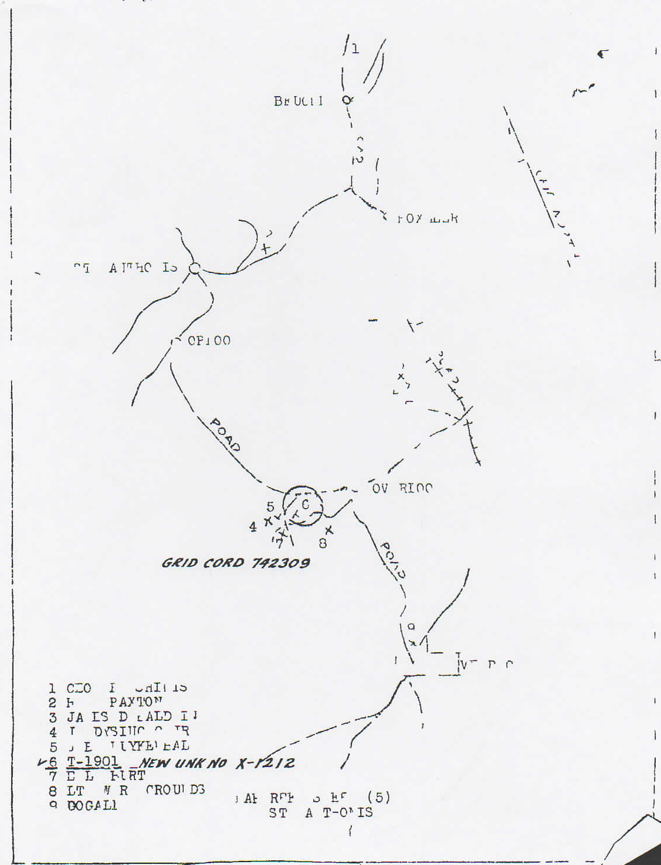

Map 1 - Joseph Ferrari recovery map

The following men are Kamphoefweg area recoverees who appear on this map. The information is Name – Unit, date of death, ASN, final burial location.

**4. John M. Dysinger, Jr. – C/48 AIB, 5 Oct 44, 33 511 339, USA cemetery not yet known**

**5. Bennie J. Kuykendall: AT?/C/48 AIB, 4 Oct 44, 38516376, Liberty Cem; Stamps, Arkansas**

**6. S/Sgt Joseph J. Ferrari – C/48 AIB, 3 Oct 1944 (official 5 Oct), Margraten (T-1901, later X-1212)**

**7. Egbert L. Burt: C/48 AIB, 5 Oct 44, 38399612, Oak Park Cem; Chandler, Oklahoma**

Since I do not have the IDPFs for Dysinger, Kuykendall and Burt, their locations on my composite map will be based on Ferrari’s definite location and their location on this map in relation to his location, using the roads on the 1:100,000 ‘s Hertogenbosch map (the source map for Ferrari’s map) and converting those to the 1:25,000 St Antonis map on which I am creating the composite map.

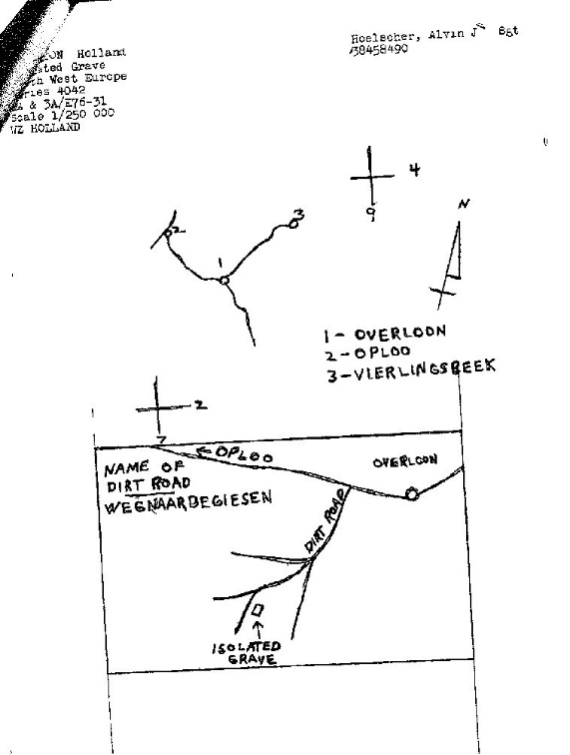 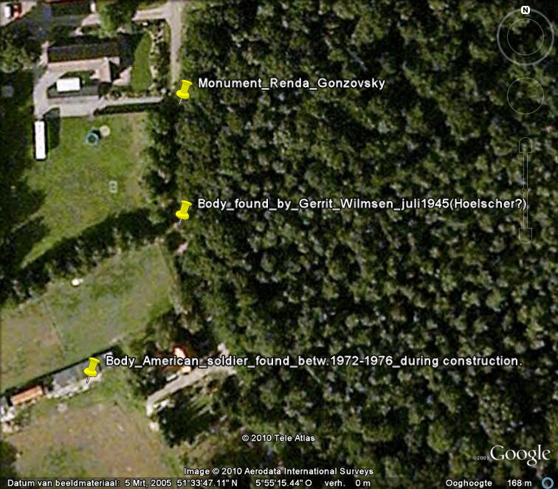

Map 2a –Alvin Hoelscher recovery map Map 2b- Piet Peters Map

**2 - Hoelscher Report. – by Piet Peters (28 July 2010)**

The statement from Gerrit Wilmsen from 8 March 1946 is confirmed by his nephew Siebert Wilmsen.

Siebert also pointed out the correct spot where the body was found. It was very close to the place where the bodies of Renda en Gonzovsky where found, just 40 meters south on the same side of the road.

On the same google map you see another pinpoint, during the construction, workers found another body of an American soldier. This was aprox. Somewhere between 1972 – 1976, the correct year will be provided asap. The name of the soldier was not known by Siebert. [*WJ: Robert Whitley A/33*]

The name of the dirt road “weg naar de giesen” is not correct, nor Siebert nor some elder people from our village are familiar with the name, but this wil also be closer investigated.

**3 - Lester Golden – C/48 – KIA 5 Oct 1944 – Recovered by British**

Narrative Report: “The remains were originally found by the son of Mr. Martinus Hendiks, living at Peelkant C192, Overloon, Holland, while digging in the garden. The original disinterment of the deceased was accomplished by the British, and the remains were evacuated to the British Military Cemetery, Junkers Bosch, Holland and reburied in an individual grave near the British plots. Disinterrment was made on 16 March 1950, and the remains evacuated to CIP, USMC, Neuville, Belgium.”

British Transfer of Remains to American Graves Registration (16 Mar 1950): Body found at “Sht 52 1/50,000, 742309”

# Key to the 5 Oct 1944 composite map

Red are those who died 5 Oct 1944 on the maps showing multiple dates.

**\* indicates men whose location is particularly uncertain.**

1 = Ferrari & Golden (742-309) C/48 KIA 5 Oct 1944 [#6 on Ferrari map]

2 = Burt C/48 KIA 5 Oct 1944 [#7 on Ferrari map]

3* = Dysinger C/48 KIA 5 Oct 1944 [#4 on Ferrari map]

4 = Renda & Gonsowski Monument C/48 KIA 5 Oct 1944

5 = Alvin Hoelscher C/48 KIA 5 Oct 1944

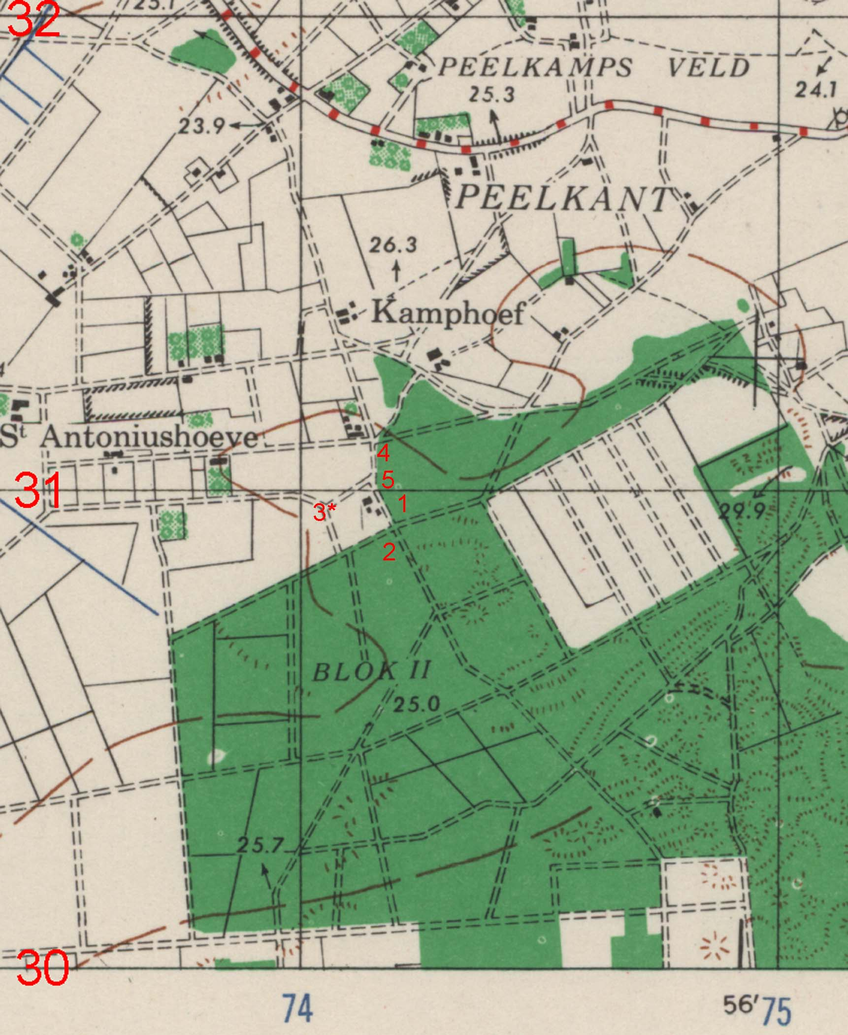

1:25,000 St. Antonis Map

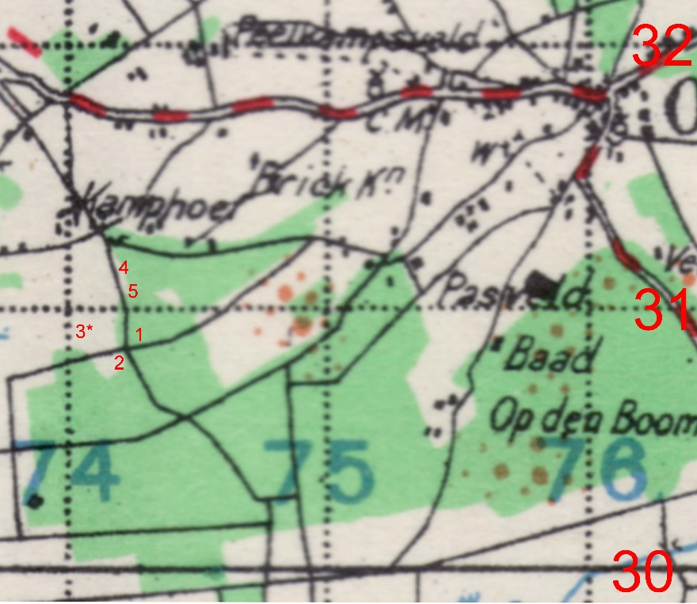

1:100,000 ‘s Hertogenbosch Map