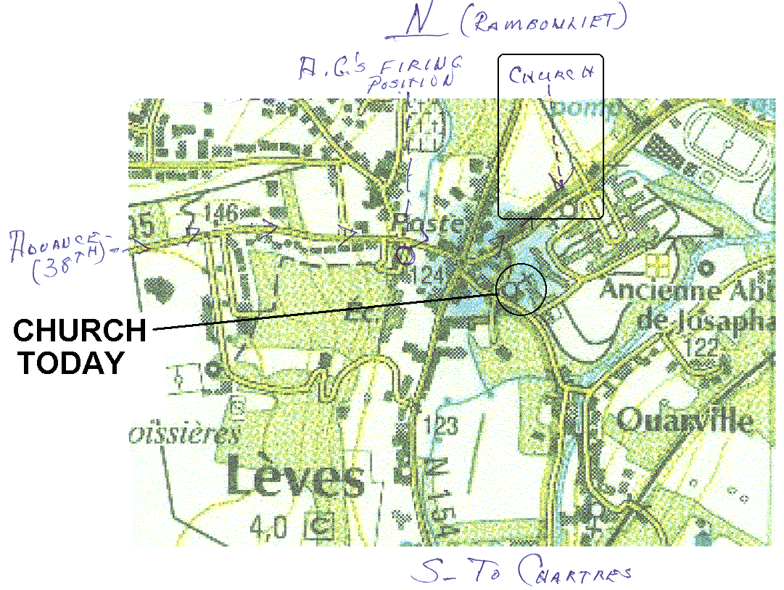

The Lèves church today is on the road that comes southeast from the main road junction. Are you sure about the location for the church that you have indicated, along the road that comes northeast from the main road junction?

