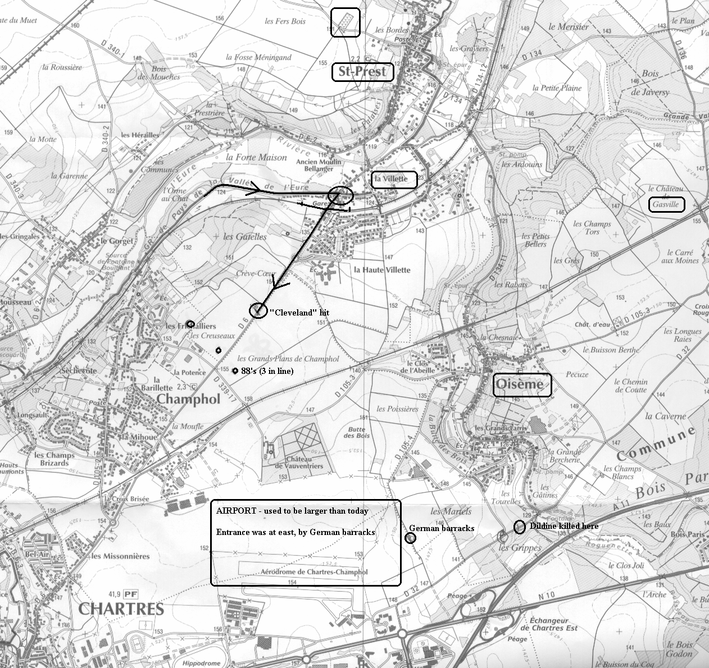
1:25,000 Map of Area Northeast of Chartres: La Villette, St. Prest, Oiseme, Airport. On August 16, 1944, C/38 AIB moved from Leves to La Villette along the road indicated, on the south side of the Eure River. The column then made a sharp right turn at La Villette and headed south toward Chartres. The Germans had set up an ambush and let some half-tracks go through and then fired on the other vehicles. Harry Retort was probably wounded in this combat in La Villette. He died of his wounds on August 19. The C/38 half-track “Cleveland” was hit by an 88 (one of the three lined indicated to the south) and destroyed at the circle south of La Villette, killing the driver, Andrew Slavik, and assistant driver, Edward Swanson. The explosion probably also killed Gayther Adams about 30 yards away. On August 18, 1944, A/38 was based at Gasville and moved against the airport entrance. Ned Dildine was machine gunned at the spot indicated south of Oiseme, from the woods just to the west: the German was in the edge of the woods along the south side of the road. Adams, Slavik and Swanson were all buried by the French at the community cemetery (highlighted) at St. Prest on August 18.

