31st Tank Bn Records of Action of Night of 15-16 August 1944
Relating to the tank buried at Chartres
compiled by Wesley Johnston
© 2008, Wesley Johnston

The records follow the four maps that I have provided: After Action Report, detailed citations of awards, Morning Reports. My evaluation follows at the end.

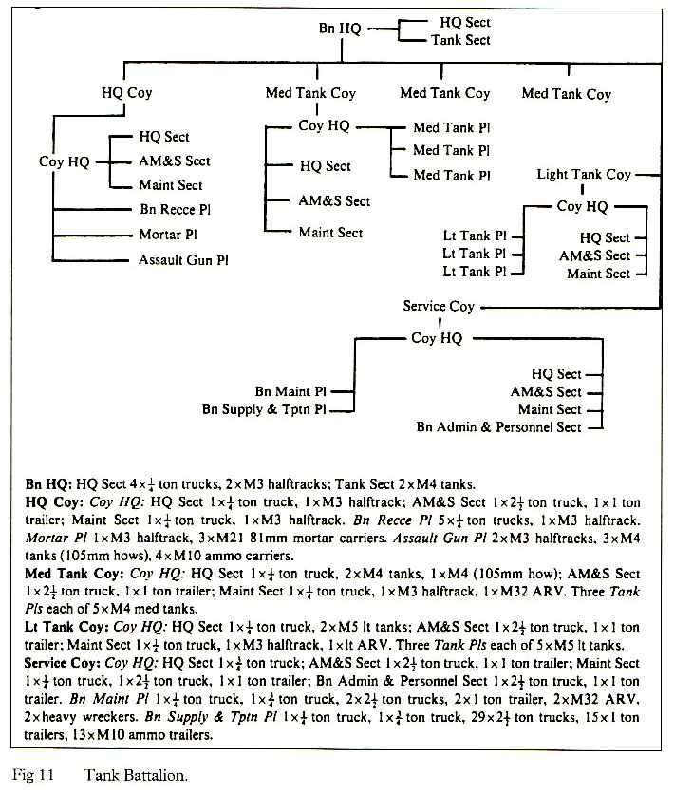
Armored Division Tank Battalion TOE (from George Forty’s book)

Note that the buried tank was an M5 Stuart light tank. The Table of Organization and Equipment shows M5 tanks only in Company D. The two Battalion HQ tanks were M4 medium tanks. The three Headquarters Company tanks were M4 medium tanks. The A, B and C company tanks were all M4 medum tanks. There were no M5 light tanks in the TOE, other than those of Company D.
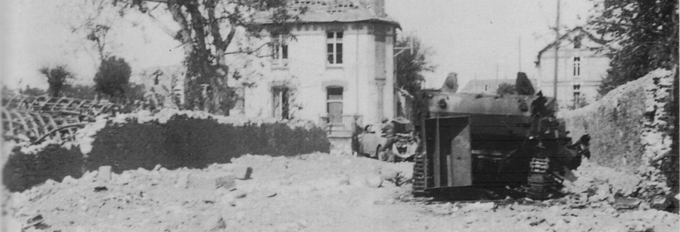
Photo (before it was burned) of the tank believed to be the one that was later buried.
This does appear to be a light tank, and the tank that was exhumed in 2008 was a light tank.
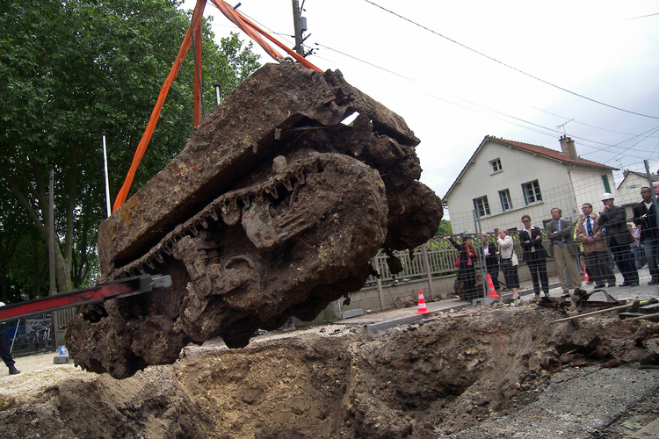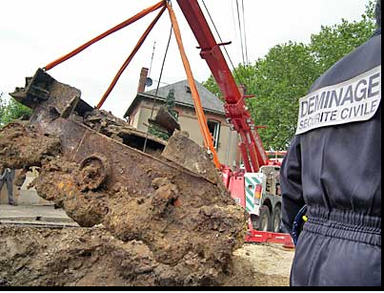
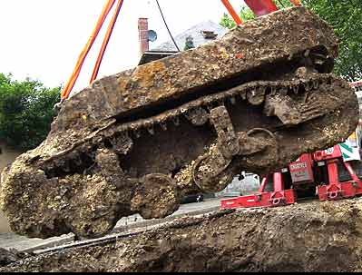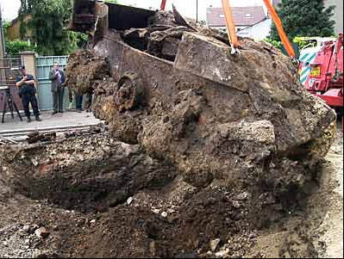
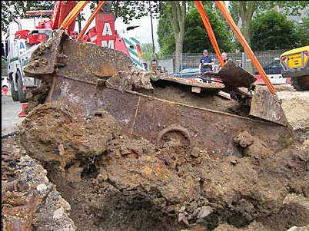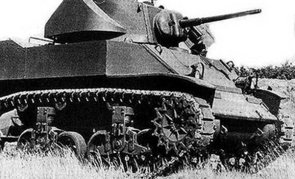
View of an M5 light tank
Maps

Map A was the map that was included with the 31st Tank Bn After Action Report. The arrows of relevance to the events of the night of 15-16 August 1944 that led to the loss of the tank that was buried in 1944 and dug up in 2008 are the two in the lower left, showing “Route F#2” and “Attack of F#2 Night of Aug 15”. This map shows the attack going on into Chartres, which is what wound up happening, though only Company “C” made the last attempt to move into the center of Chartres.

Map B is a modern map. The red star marks the approximate location where the tank was buried. The black arrows indicate the planned route. However when it was found that the bridge over the Eure had been blown and when stiff resistance was met, since this area was the main area of the German garrison at Chartres, the arrow pointing to the east never actually happened, with the apparent exception of the single tank that was later buried.

Map C is a map of the 1944 era, on which the towns of Luisant and Bonville have been marked. It is very easy to see on this map how the plan to go to Luisant and then head east across the Eure River towards Bonville would be a logical route. Note that the apparent road from Luisant to Bonville is not in fact a road but the cross bar of one of a series of crosses that were indicating some feature on the map (another cross in this series can be seen at St. Georges)

Map D is a modern closeup that shows the approximate location of the buried tank (red star, as shown on the TF1 television Google Earth map), as well as the locations of Luisant, Le Coudray, the Parc du Gord, and the modern location of the Eure River. Apparently in 1944, the Eure River bridge was much closer to the location of the tank.

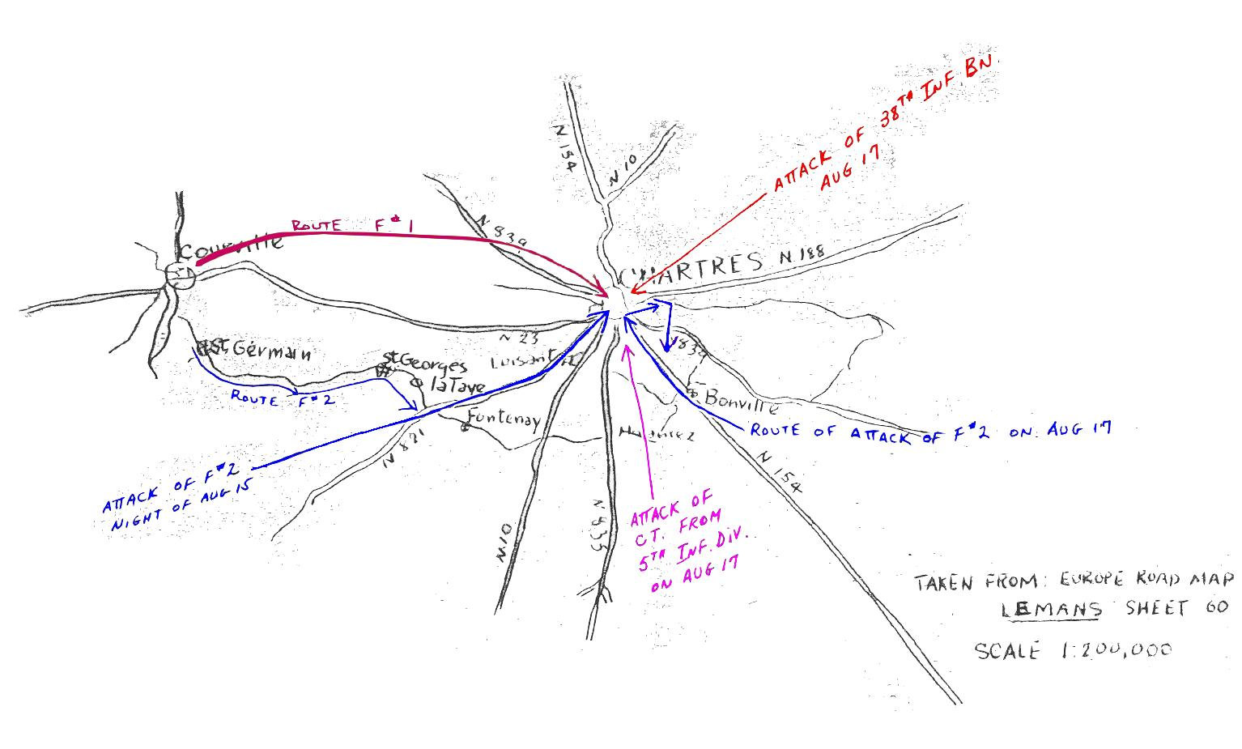
Map A
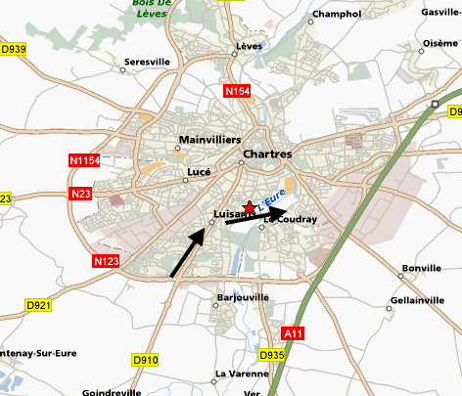
Map B
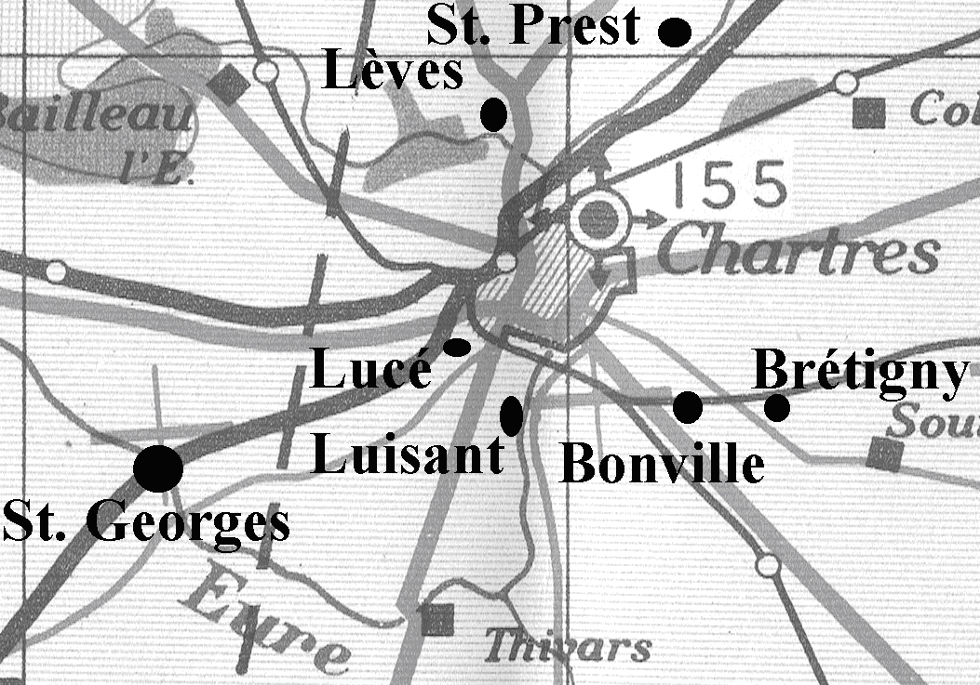
Map C
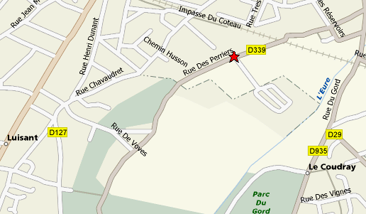
Map D
31st Tank Battalion After Action Report
15-16 August 1944

The forces moved to the East on their assigned routes of advance -- Force #2 moving through St. Germain, St. Luperce, St. Georges, and La Taye. The general plan of Force #2 was to turn to the Northeast when they hit Highway 821 which is the main road from Illiers to Chartres -- advance through Luisant -- and then attack straight East -- cutting South of the city of Chartres itself, and ending up in assembly areas Southeast of Chartres -- thus getting in behind the city.
Co "A" of the 31st Tank Bn and Co "C" of the 23rd Armd Inf Bn who were spearheading the advance ran into hasty mine fields and heavy enemy fire on the approaches into Luisant. The Engineers went forward to breech the minefields while Co "A" of the 31st Tank Bn went into firing positions along a ridge about 1-1/2 miles South of Luisant and covered the dismounted advance of Co "C" of the 23rd. Meanwhile the 434th F.A. which was in direct support of Force #2 went into firing positions and assisted by heavy Corps Artillery began to blast the enemy positions.
As the fighting continued throughout the afternoon, heavy toll was taken of the enemy forces. Around 1500 enemy artillery started dropping air bursts on our troops, but they were finally silenced at 1800 by Corps and Divisional counter-battery fire.
As the fighting died down to the Southwest of Luisant, reports reached us that Force #1 to the North had fought their way into the Northeast approaches of the city of Chartres itself. It was decided to send Co's "A", "B" and "C" of the 31st Tank Bn and Co "C" of the 23rd Armd Inf Bn on a night attack into Luisant -- cut to the East as planned in the original mission and go into the planned assembly areas to the Southeast of Chartres. At the same time, Force #1 was to launch an attack into the city from the Northwest. Co "C" of the 31st was to leave Force #2 as they passed through Luisant and drive on into Chartres to assist Force #1 in mopping up the city of Chartres.
H-hour was at 2130 -- and Force #2 launched the attack as planned. The force ran into murderous anti-tank fire, flares, and mines in the outskirts of Luisant and the two rear tank companies were forced to withdraw to their alternate rallying positions. Co "C" of the 31st went on into Chartres as planned, but were unable to gain contact with Force #1 and after suffering casualties of both vehicles and men, they became quite disorganized -- especially after their Company Commander was killed and the Battalion Commander's tank was blown up. The remaining elements were reorganized and pulled out of the city to the South where they went into an assembly area -- rejoining the Combat Command on the morning of the 16th.
31st Tank Battalion Detailed Citations for Actions on 15-16 August 1944

15 August 1944 Actions

Headquarters

CITATION FOR SILVER STAR

MAJOR LESLIE A. LOHSE (Army Serial Number 0409019), Cavalry, 31st Tank Battalion, United States Army, for distinguishing himself by gallantry in action on 15 August 1944, in the area of Chartres, France. As acting battalion commander he was ordered to attack the city of Chartres. Because of its strategic importance, the enemy had anti-tank weapons of all types emplaced throughout the city proper and its outskirts. Although realizing that storming this virtual fortress would be a hazardous and costly operation, Major Lohse rode in the vanguard of the attacking force. His tank was set ablaze and put out of action by an 88mm shell and anti-tank rockets. Under a hail of machine gun and rifle fire he aided in putting out the fire and took cover only after other members of the crew had done so. He concealed him-self in an enemy headquarters for a time, and then made his way through enemy lines to rejoin his unit three days later. Major Lohse's fearless leadership and courageous example were an inspiration to the men who fought under his command.

CITATION FOR BRONZE STAR MEDAL

MAJOR WILLIAM R. BEATY (Army Serial Number 022672), Cavalry, Headquarters 31st Tank Battalion, United States Army, for distinguishing himself by heroic achievement in connection with military operations against an enemy of the United States on 15 August 1944, in the area of Chartres, France. In his capacity of executive officer he led a night attack by his tank force on the city. After advancing well into the city, the attack was halted by a desperately resisting enemy. Gathering together the remanants of the attacking force, he marched them under murderous close range fire to an assembly area in the outskirts of the city. After reorganizing it under fire, he led them to the Combat Command rallying position. Major Beaty's prompt action, efficient leadership and courage were instrumental in preventing virtual annihilation of the major portion of the command.

Company “B” (Medium Tanks)

CITATION FOR SILVER STAR

CAPTAIN CLAUDE GARLAND, JR., (Army Serial Number 01010131), Cavalry, Company "B", 31st Tank Battalion, United States Arty, for distinguishing himself by gallantry in action in connection with military operations against an enemy of the United States on 15 August 1944 in the area of Chartres, France. In the attack upon Chartres, the tank which Captain Garland was commanding came under heavy fire, began to burn and toppled helplessly into a deep shellhole. The crew was unable to extricate itself and in imminent danger of perishing in the flames. Ignoring the concentrated and accurate shelling in which the vehicle was being subjected, Captain Garland succeeded in reaching the door of the tank. Despite his completely exposed position, he kept the door open and assisted each member of the crew to evacuate the stricken vehicle. After the tank had been completely destroyed by enemy fire, Captain Garland led his men safely back to their own lines, crawling under fire for two miles with a painfully sprained ankle.

Company “C” (Medium Tanks) – Main Thrust to Center of Chartres

CITATION FOR OAK-LEAF CLUSTER (SILVER STAR)

FIRST LIEUTENANT GEORGE J. RACINE (Army Serial Number 01013889), Infantry, Company "C", 31st Tank Battalion, United States Army, for distinguishing himself by gallantry in action in connection with military operations on 15 August 1944 in the area of Chartres, France. During the night attack on Chartres, 1st Lt. Racine was serving as platoon leader, riding in the third tank of the column. The enemy forces were strongly emplaced in innumerable concealed positions throughout the city, and had the outstanding advantage of observation from the lofty Cathedral Towers which the Allied Armies had orders not to destroy. Fire from close-range bazookas and anti-tank mines killed the company commander in the lead tank and knocked out the second vehicle. Without hesitation 1st Lt. Racine took over command of the column and led it through heavy fire to the center of town. Enemy volleys wrecked a half-track in the column, cutting off the second and third platoons. Receiving word by radio of their plight, Lt. Racine unhesitatingly stopped his tank, stepped out into the fire-swept street signaling his location with a flashlight. Later, ignoring the cross-fire of machine guns from the many windows which faced the street, he made his way back to the enemy-infested square. Quickly he cleared away the shattered half-track, reformed the disorganized column and led the company out of the town. Taking over the unit, Lt. Racine instilled new confidence into the men, and rallied them for a dawn attack. By his outstanding leadership and unremitting courage, Lt. Racine saved the column from catastrophic defeat and gained for himself the unrestrained admiration of his men.

Company “D” (Light Tanks)

CITATION FOR BRONZE STAR MEDAL

SECOND LIEUTENANT GUS W. ENSKAT (Army Serial Number 01019132), Infantry, Company "D", 31st Tank Battalion, United States Army, for distinguishing himself by heroic service in connection with military operations against an enemy of the United States on 15 August 1944, in the area of Leves, France. 2nd Lt. Enskat was leading his tank platoon on a mission when it was fired upon from highground commanding the road. He ordered his platoon to return the fire and succeeded in taking the hill. When firing had ceased, he dismounted, proceeded up the hill, and accepted the surrender of two officers and 48 enlisted men. After turning over his prisoners to other troops he and his platoon continued on its assigned mission. His determination to complete his mission regardless of the obstacles and his effective leadership is in keeping with the highest traditions of the Service.

16 August 1944 Actions – Not Related to Buried Tank

CITATION FOR BRONZE STAR MEDAL

Staff Sergeant Joseph Arasin (Army Serial Number 33075225), Infantry, United States Army, for distinguishing himself by heroic achievement in connection with military operations against an enemy of the United States on 16 August 1944, in the area of Bonville, France. While serving as a medium tank platoon leader, S Sgt. Arasin led four tanks in reconnaissance of a bivouac area. Stopped by a sudden encounter of heavy fire from enemy tanks, anti-tank guns and infantry weapons, three of the vehicles immediately started back toward their command. Although he himself was grounded by a shell fragment and his tank hit twice by anti-tank fire, S Sgt. Arasin rallied his platoon and directed an orderly withdrawal. His cool and courageous leadership while painfully wounded reflects credit upon S Sgt. Arasin and the Armed Forces.
Morning Report Locations & Record of Events

Date | Bn HQ | Co B | Co C | Co D
1944-Aug-15 | Chartres, [France] A-11.5-03.2 / Engaging enemy near Chartres France | Chartres [France] UC A-11.5-03.2 / Left Cormas 1600 14 Aug 44 Engaged the enemy 0500 at present location | Chartres, [France] A-11.5-03.2 / Left Cormes 14 Aug 44 arr vicinity of Chartres prepared for night attack on present location at 2200 | Chartres, [France] A-11.5-03.2 / Left Courville 1130 in contact with the enemy West of Chartres
1944-Aug-16 | Chartres, [France] A-11.5-03.2 / In action against enemy near Chartres France | Bonville [France] / Left Chartres 15 Aug 44 Arr 1 mi NE of Bonville 1025 | Chartres, [France] A-11.5-03.2 / Entered Chartres 15 Aug 44 2215 received tremendous enemy fire Three of our tanks were knocked out in the city | Chartres, [France] / Co in Biv 1 mi W. of Chartres

Evaluation of these reports for Buried Tank
by Wesley Johnston

The tank could only have been a part of Force #2, which attacked that area south of Chartres (what is now part of Chartres) where the tank was buried. The only other force attacking Chartres that day (15 August 1944) was Force #1 to the northwest of the city (see Map A, red arrow at upper left).

Force #2 intended to drive north to Luisant and then turn east and attack eastward and assemble southeast of Chartres. However, the German garrison for Chartres was in this area, so that they ran into very heavy resistance. In addition, the bridge over the Eure River was blown, so that they could not go eastward from the rue des Perriers.

So the 31st Tank Battalion was very definitely in the area where the buried tank was recovered. The problem is that the only light tanks of the Battalion were NOT in the area. As the TOE shows, the only light tanks in the Battalion were those of Company “D”. Company “D” does not appear at all in the After Action Report as having been involved with Force #2. In fact, the Morning Reports of Company “D” show that it was west of Chartres on August 15 and 16, apparently separated from the rest of the Battalion. The one detailed citation for a D/31 man further confirms this, since the citation is for events at Lèves, northwest of Chartres, where Force #1 was attacking.

So how did a light tank of 31st Tank Battalion wind up on rue des Perriers with Force #2 on the night of 15-16 August 1944?

This question remains a mystery, since the records show that D/31 was northwest of the city and not south of the city that day. In fact, the 23 Armored Infantry Battalion report of the actions of Force #1 clearly places D/31 with Force #1 and not with Force #2:

The first enemy resistance was encountered at 1430 on the western side of Chartres, as the battalion [23 AIB] was moving to outflank the city. Four enemy antitank guns opened fire on the force column, knocking out one light tank of company "D" 31st Tank Battalion.

It is possible that, late in the day, D/31 was brought from Lèves to rejoin the Battalion south of Chartres for the night attack. But there is no evidence of this, and the August 16 Morning Report continues to locate the company west of Chartres, while the rest of the Battalion was east of Chartres. So it really does seem highly unlikely that D/31 was at rue des Perriers on the night of 15-16 August.

Another possible answer is that the buried tank may have been a loner, a D/31 tank that had been separated from D/31 and remained with the Battalion. That is my best guess.

In his 1994 book, Roger Joly tries to figure out where the abandoned tank came from. His speculation is that it came from the north, and he notes that the tank went by the house of M. Ouellard at the foot of rue Saint Brice. So it does seem likely that it did come from the north. In that case, it may have been a D/31 tank that was attacking with Force #1 from the northwest and made it all the way through the center of the city (it is easy to get lost in those winding short streets) and come all the way down to the zone of Force #2.

This actually seems to fit in some other ways. The foot of rue Saint Brice is very near rue des Perriers. And the location identifed in the 1982 tesimonial as “la sente des Galichets” is shown on the modern map just north of rue des Perriers as “Sentier des Gallichez”. This is the place that M. Ouellard said was where the men in the tank fled. That means that they fled north, which was probably back the way that they had come.

And who was in the tank?

This question can be somewhat addressed. The French wire service report claimed that the tank was the one in which Maj. Leslie Lohse was riding. Maj. Lohse was acting Battalion commander in this action. His Silver Star citation says that he rode in the vanguard of the attack. The After Action Report does not give any specifics about who was where during the attack. But Maj. Lohse’s citation says that the tank that he was riding was hit by an 88 and set ablaze, though Lohse and others put the fire out. So this question too can not be resolved one way or the other from the records shown above. But I find it unlikely that this tank of Maj. Lohse – hit by both an 88 and an anti-tank rocket – was the one that apparently suffered only the loss of a tread from being hit by a rocket. So I do not think it is likely that Maj. Lohse was riding in the light tank that was buried and that it is much more likely that he was in a more severely damaged medium tank not far away. But that still begs the question of just who was in the light tank that was eventuatlly buried?

This road which was then N821 is now D921.
This was Capt. Willie W. Oliver. Other C/31 deaths August 15 were Cpl. Harry H. Parthemore and Sgt. Walter F. Dalley. B/31’s S/Sgt. Johnnie A. Meade was also killed this day, as was D/31’s S/Sgt. Winfred V. Hensley. D/31’s Sgt. Norman R. Miesner was wounded this day and died of his wounds the same day.
Capt. Willie W. Oliver

