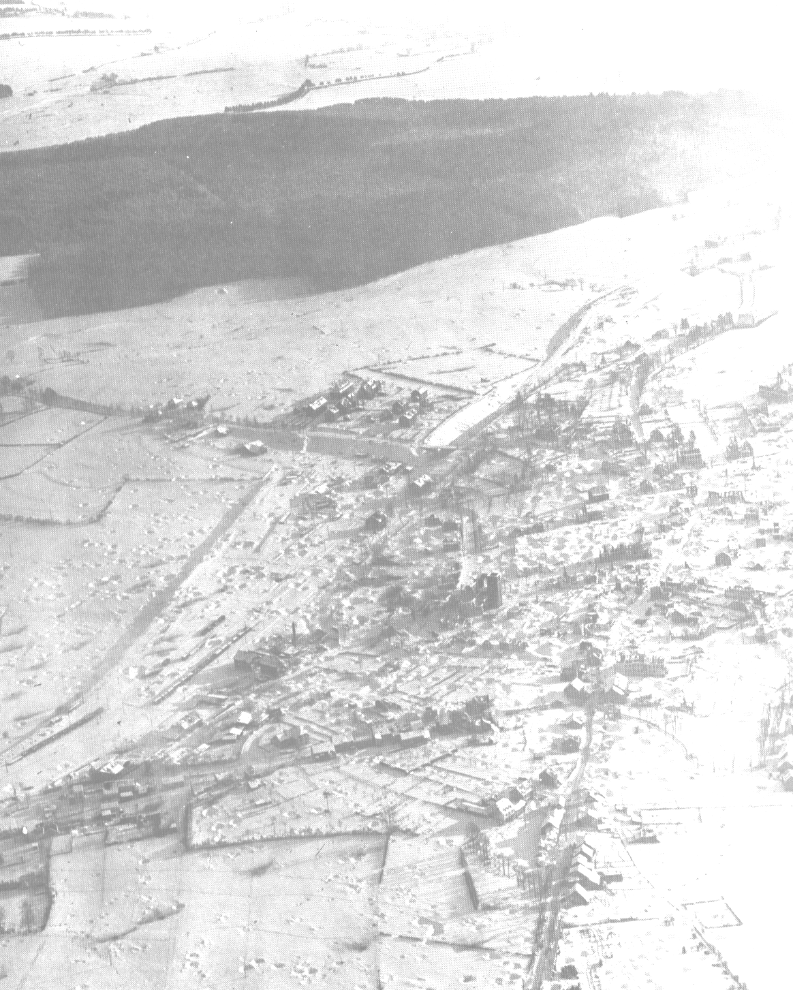
St. Vith, Belgium - January, 1945

