WWII Photographs of Donald William Ketchem,
C/23AIB, 7th Armored Division
Photos thanks to his grandson Andrew Morrison

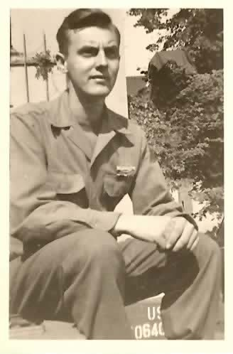
01 Donald William Ketchem, 1945
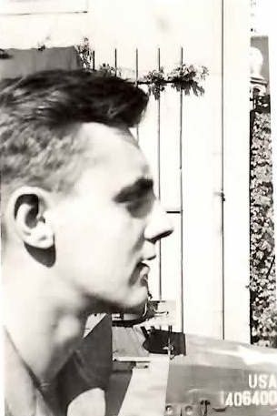
02 Donald William Ketchem, 1945
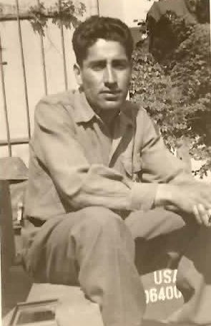
03 Esmile Carrillo, 1945
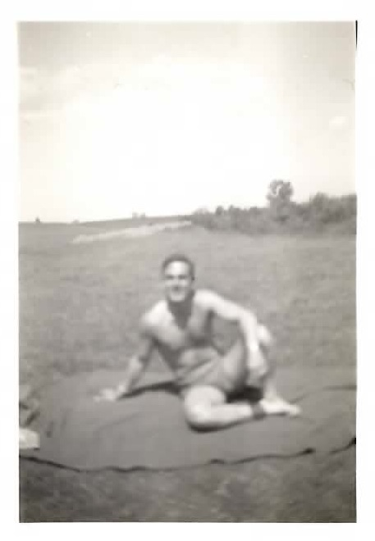
04 Charles Gross, 1945
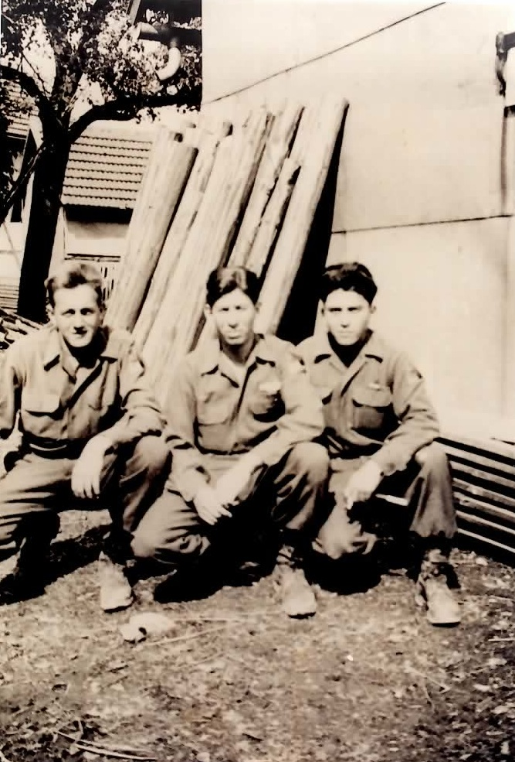
05 Virgil O. Ginter; Henry Lucero; Robert D. Cordova
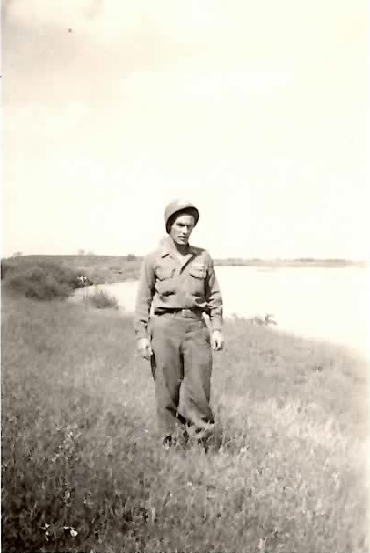
06 Floyd Bratt
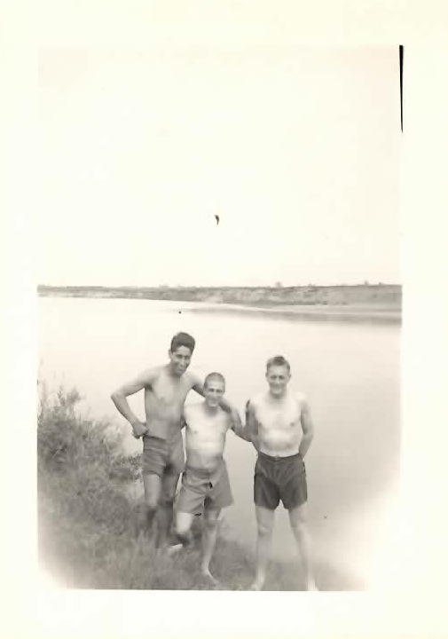
07 Esmile Carillo; Salvatore Maone; Virgil O. Ginter - (Elbe River)
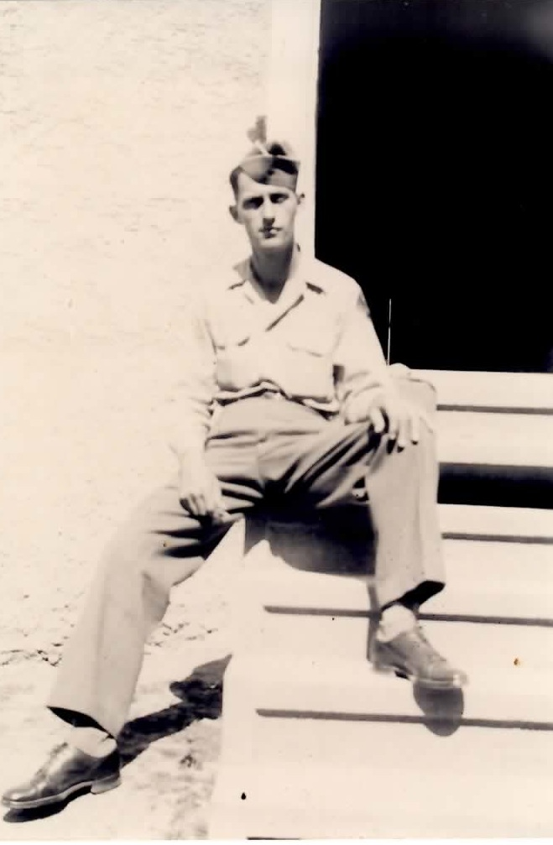
08 Chalmer Currington
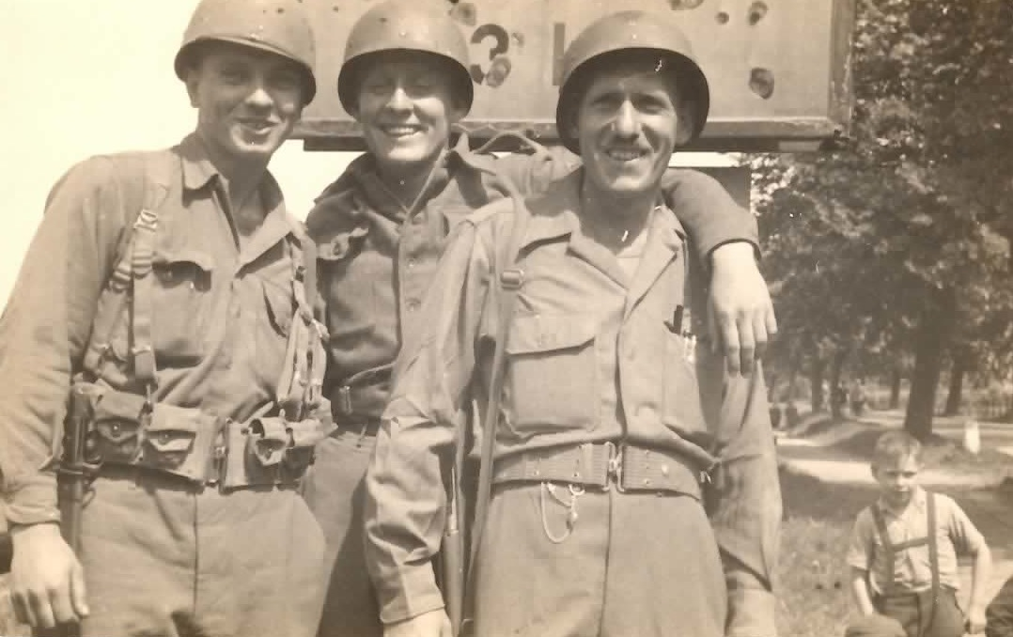
09 Walkowski; Hood; Calovi (May, 1945)
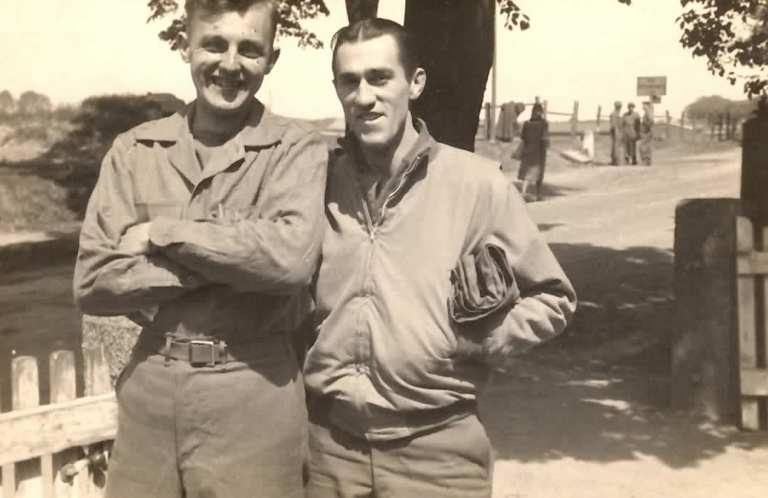
10 Donald William Ketchem; Treffley N. Bourdeau
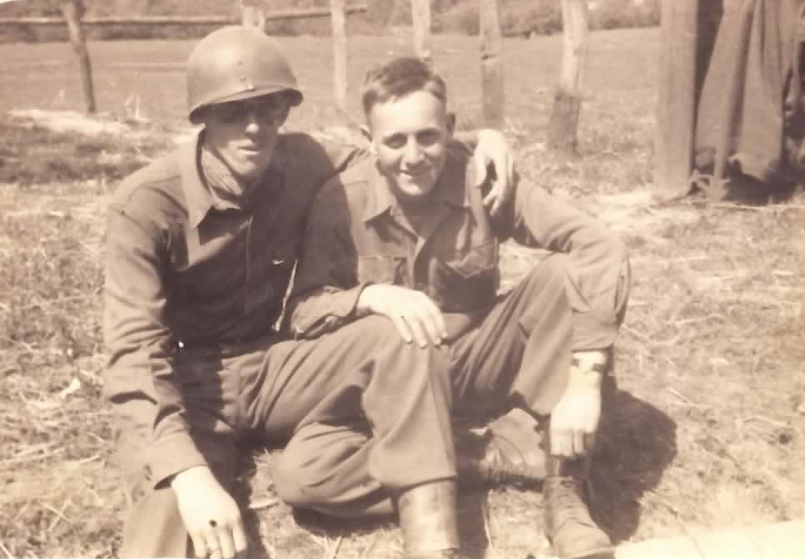
11 Norwood L. Conant; Virgil O. Ginter
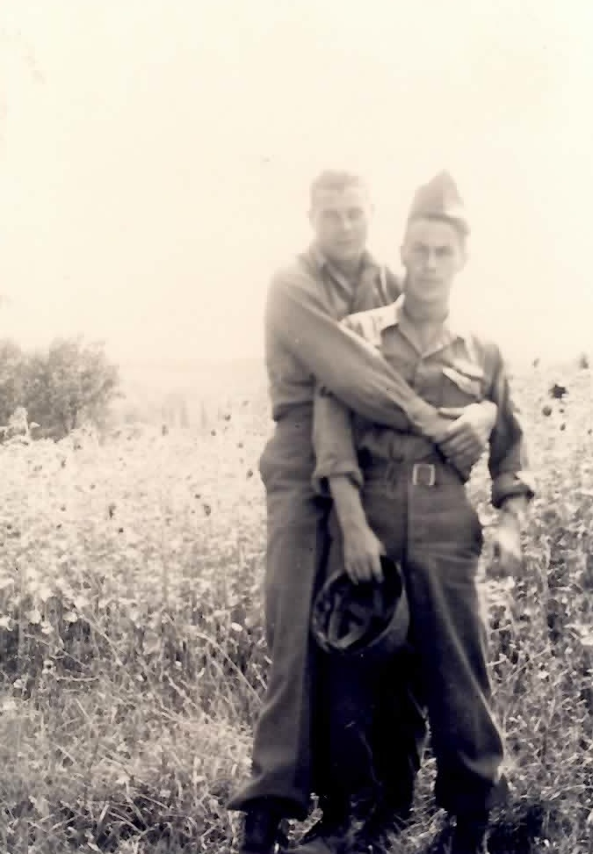
12 James E. Sledge; Floyd Bratt
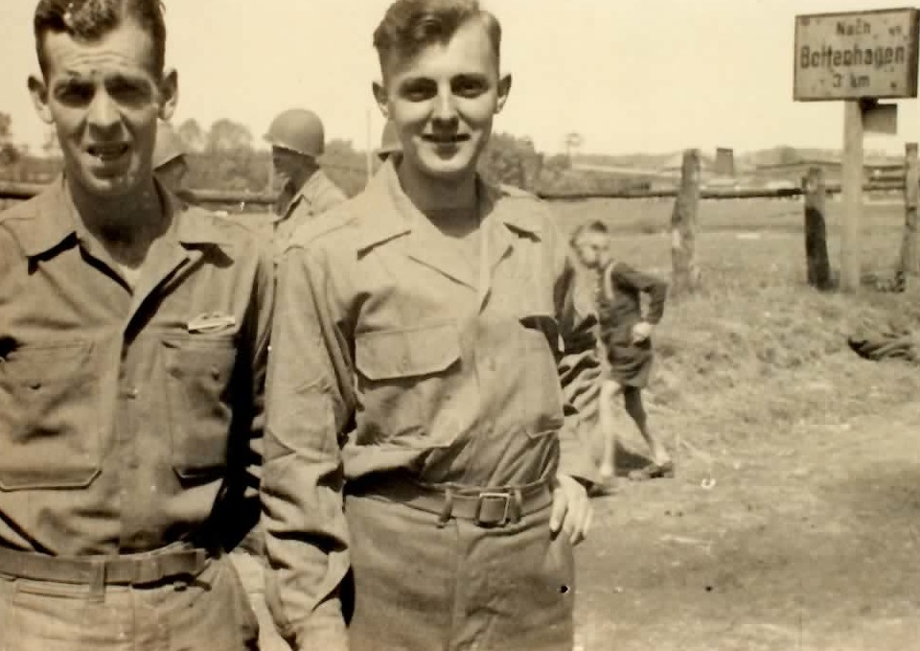
13 Herbert Bell; Donald William Ketchem (Batenhagen)
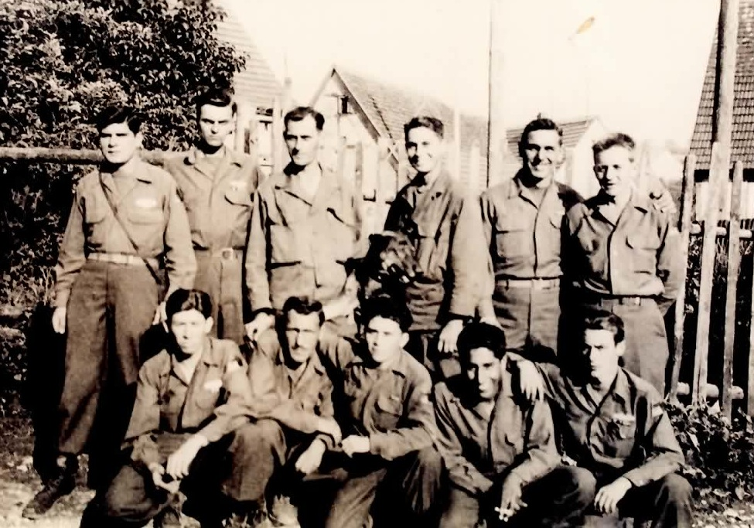
14 (Kneeling, L to R) Henry Lucero, Alfred Calovi, Robert Cordova, Esmile Carrillo, Floyd Bratt; (Standing, L to R) Frank Macek, Don Ketchem, Chalmer Currington, Dewey Hughes, Charles Gross, Virgil Ginter.
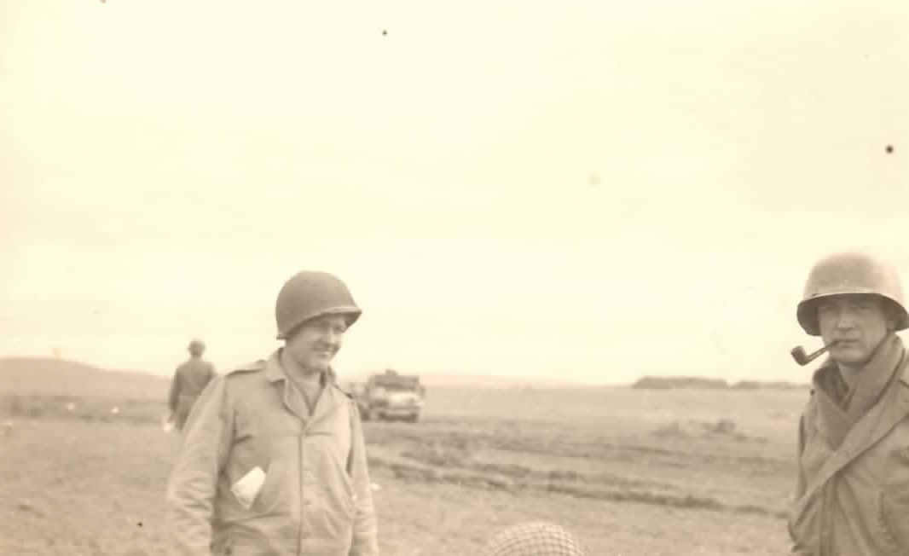
15 Raymond J. Bujan; Wilfred J. LaRarochelle (October, 1944, Holland)
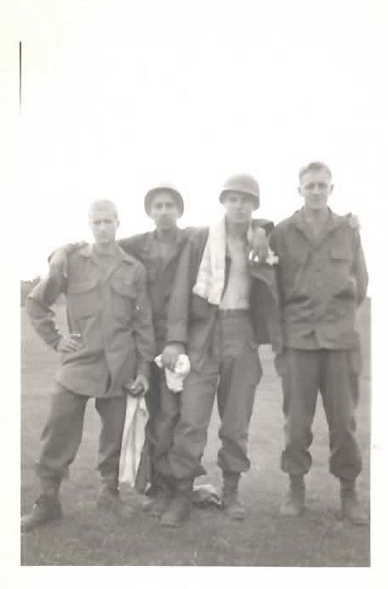
16 Maone; Carrillo; Walkowski; Ginter (1945)
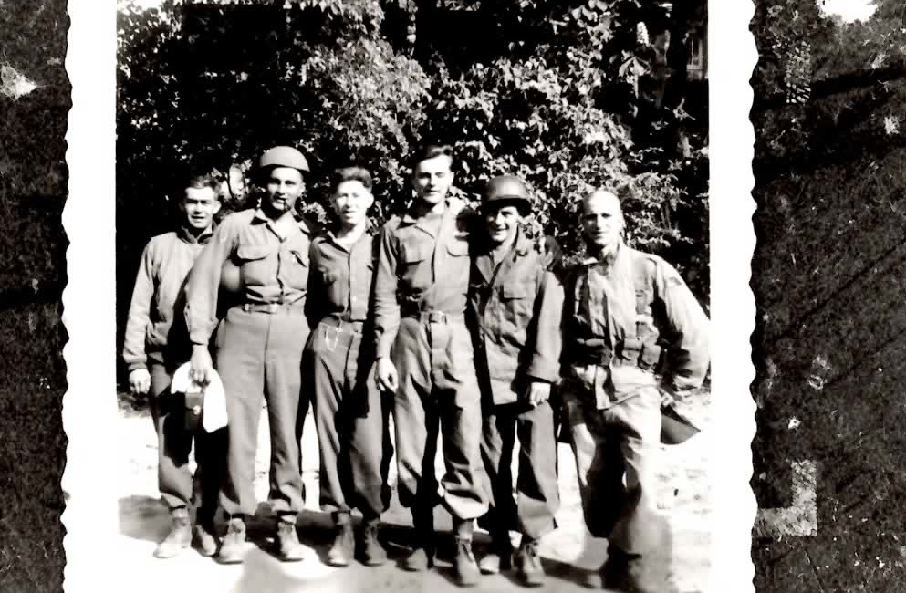
17 Unknown; Gross; Lucero; Ketchem; Unknown; Maone
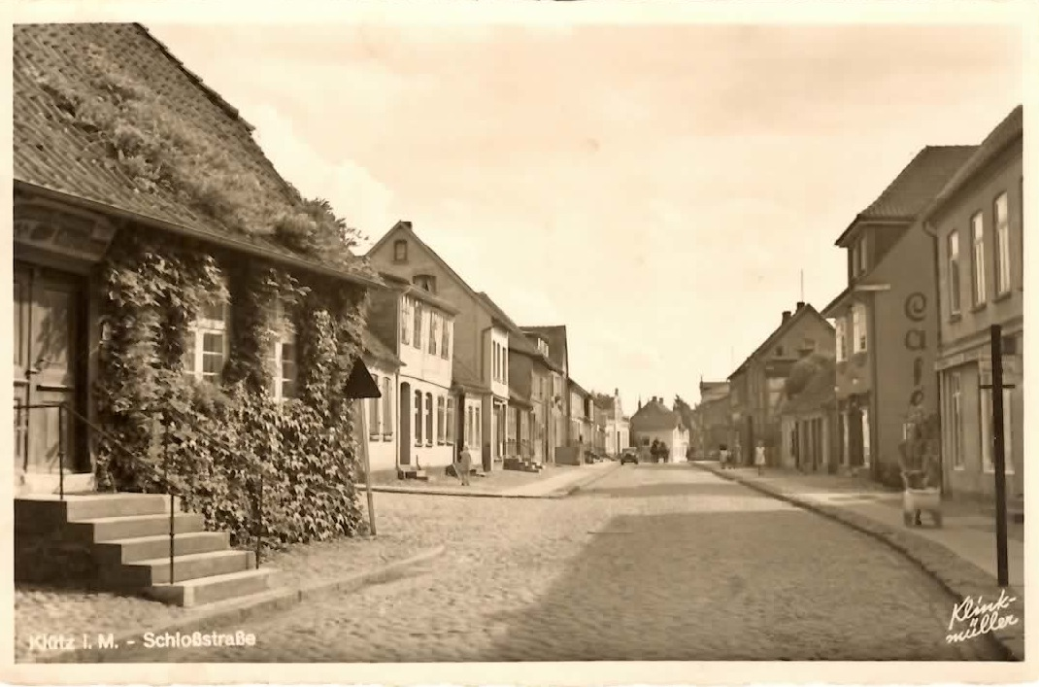
18 Klütz in Mecklenburg, Germany - Schloßstraße
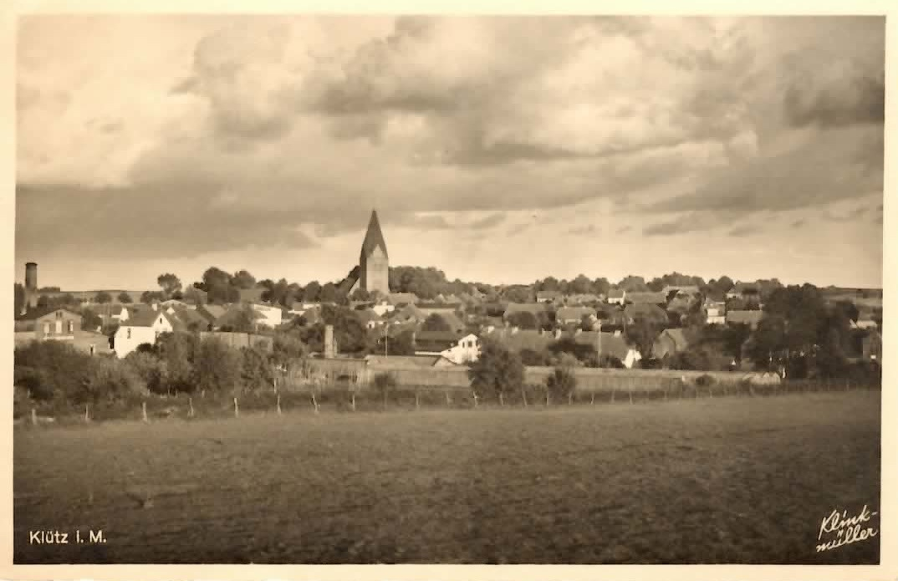
19 Klütz in Mecklenburg, Germany
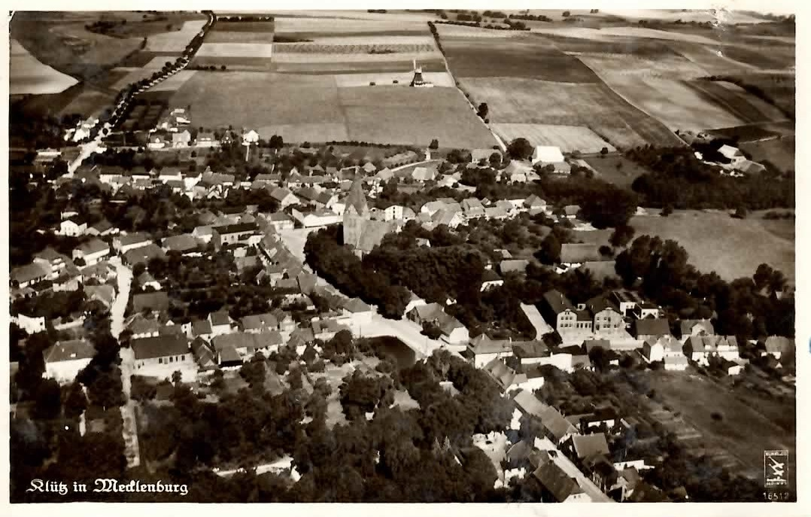
20 Klütz in Mecklenburg, Germany
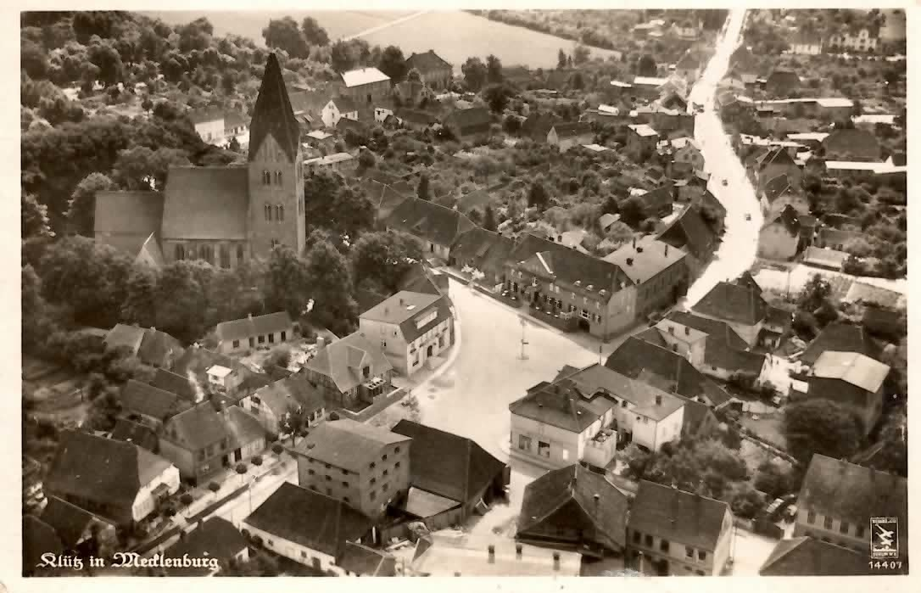
21 Klütz in Mecklenburg, Germany

